Rates & Unit Rates – RP.2 Name: _________________________________________ Period: 1 2 3 4 5
These rates have been recorded from actual world-record holders! Determine the unit rate for each one, and SHOW YOUR WORK. Then, write the unit rate below the rate. Use an emoji to show your reaction!
Record & Record Holder | Rate | Work Space | Unit Rate
Longest Human Tunnel traveled through by a Dog Skateboarder  (Otto the Bulldog)  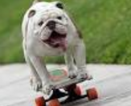 | $$\frac{150 humans}{5 tunnels}$$ |  | $$\frac{ humans}{1 tunnel}$$  _____ humans  per tunnel
Fastest Piggy Back  (Owen Larson & Jordan Botright) | $$\frac{168 minutes}{15 miles}$$
Most Toilet Seats Broken on Head  (Kevin Shelley)  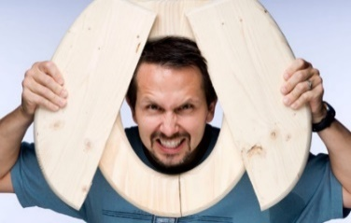 | $$\frac{2,070 toilet seats}{45 minutes}$$
Record & Record Holder | Rate | Work Space | Unit Rate
Fastest Time to Pop 100 Balloons by a Dog (Twinkie) | $$\frac{100 balloons}{40 seconds}$$
Most Balls Caught by a Dog with its Paws  (Purin the Beagle) | $$\frac{84 balls}{6 minutes}$$
Longest Nails  (Lee Redmond) | $$\frac{152 inches}{5 nails}$$
Most Big Macs Consumed  (Donald Gorske) | $$\frac{16,250 Big Macs}{25 years}$$

