Unit 5

Area & Volume

Area

Composite Area

Surface Area

Volume

Name:

Math Teacher:

Pg.1a

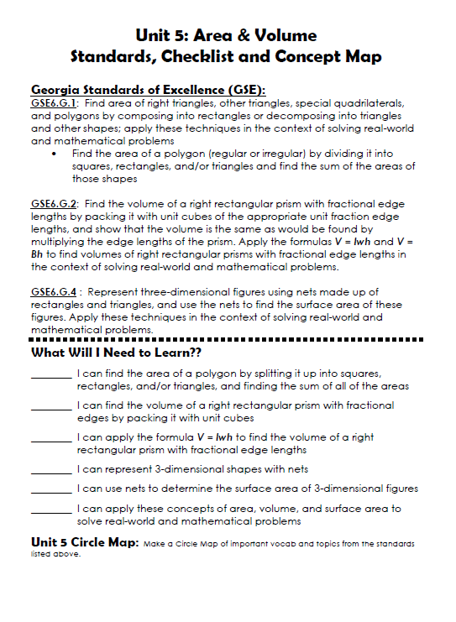

Pg 1b

1/20
Week of 1/27 Week of

Pg.2a pg. 2b

Unit 5 - Vocabulary

Term Definition and/or Picture-Example

Area

Base (of a
triangle)

Base (of a 3D
figure)

Congruent

Cubic Units

Edge

Equilateral
Triangle

Term | Definition and/or Picture-Example

Face

Isosceles Triangle

Lateral Faces

Net

Parallel

Parallelogram

Perpendicular

Pg.2a Pg. 2b

Term | Definition and/or Picture-Example

Polygon

Regular Polygon

Polyhedron

Prism

Pyramid

Quadrilateral

Rectangle

Rectangular
Prism

Term | Definition and/or Picture-Example

Rhombus

Right Triangle

Scalene Triangle

Square

Surface Area

Trapezoid

Vertex (vertices)

Volume

Pg.4a pg. 4b

Math 6 – Unit 5: Area & Volume Review

Knowledge & Understanding

- How could you determine the area of a composite figure, such as the ones shown here? 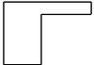

- What types of units are used to describe area?

- What types of units are used to describe volume?
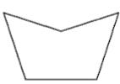

Proficiency of Skills

4) Determine the volume of the cube:
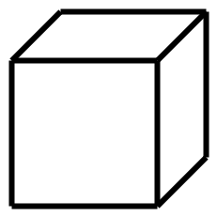

1 | cm.
3 | cm.

- Find the area of the shaded section of the square:

9 m

- Find the area of the triangle:
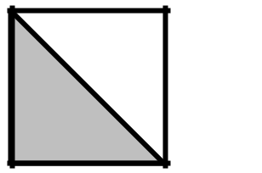
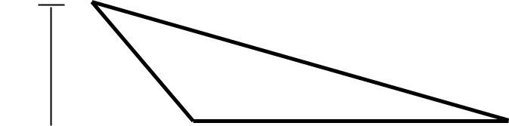

cm |  | 25 cm
 |  | 19 cm
14 |  | 19 cm
 |  | 20 cm

- Determine the area of the trapezoid:

24 cm
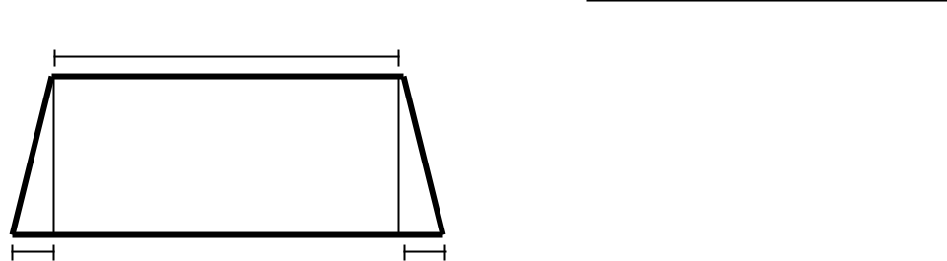

10 cm


1 cm 1 cm

- The surface area of a cube can be found by using the formula SA = 6s2. Determine the surface area of a cube with a length of 8cm.

- Find the area of the figure shown below:
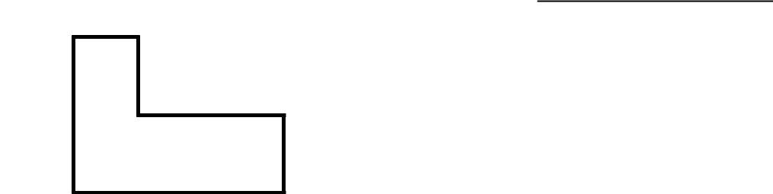
5 ft

12 ft

6 ft


16 ft

Application

- If carpet costs $4 per square yard, how much would it cost to carpet a rectangular room that is 6 yards wide and 10 yards long?

- What is the area of the trapezoid?
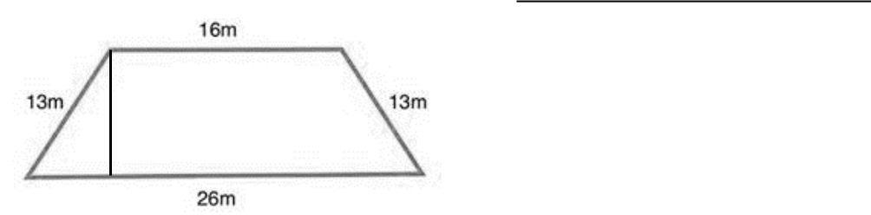

10 m

Pg.5a pg. 5b

- A rectangular prism is filled with small cubes of the same size. The bottom layer consists of 9 cubes, each with a volume of 2 cubic inches. If there are 3 layers of cubes in the prism, what is the volume of the rectangular prism?

- A box is made of cardboard with no overlap. The net of the box is shown below. How many square inches of cardboard is needed to make the box?
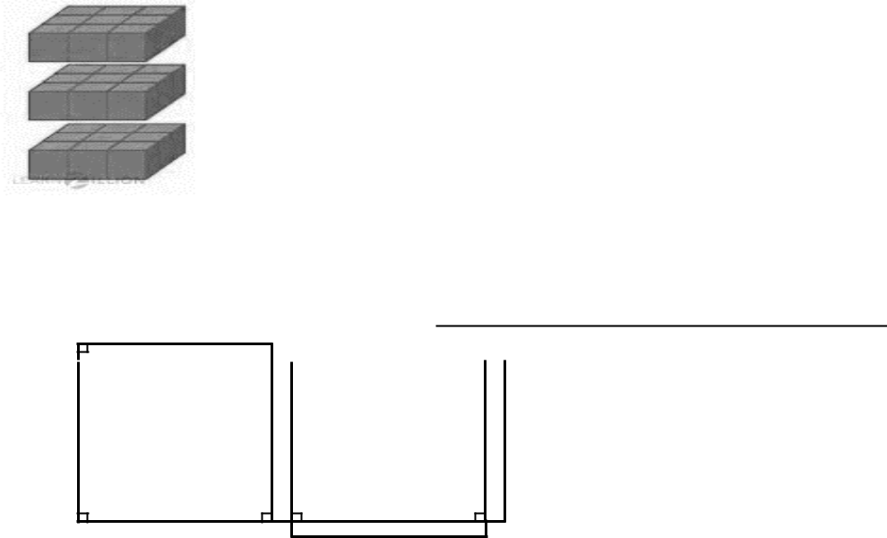

- in. 8 in.

8in.

14) Find the surface area of the net below?
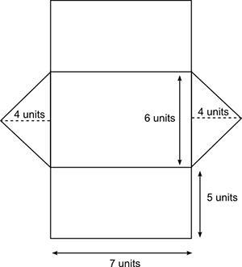

- Mariah and Max are making a plaque. The center is a 10-inch square, and the edges of the frame measure 12 inches long and 12 inches wide.

What is the area of the frame?
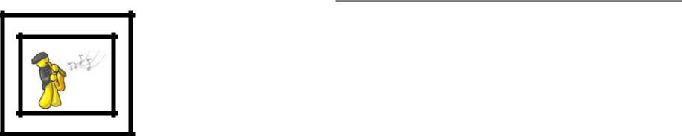
- A fish tank is shown below. What is the volume of the water in the tank?
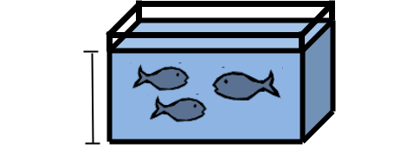

8 ½ in.

5 in.
12in.

- How many cubic feet are in a cubic yard?

- The volume of a rectangular prism can be found by using the formula V=Bh. If the base of a prism is square with a side length of 3 inches and the height of the prism is 2 ¼ inches, find the volume of the prism.

- Andres is painting five faces of a storage cube (he isn’t painting the bottom face). If each faces is 8 inches, how many square inches will he need to paint?

- Which of the following nets could NOT be folded to form a cube?
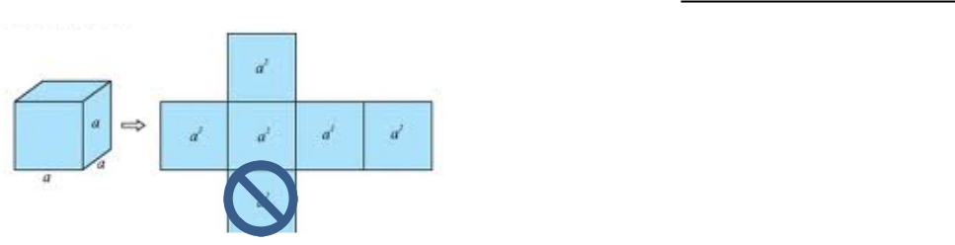
a) |  |  |  |  |  |  |  | c)
b) |  |  |  |  |  |  |  | d)
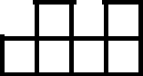
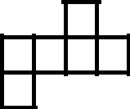

Pg.6a

12 ft


12 ft

pg. 6b

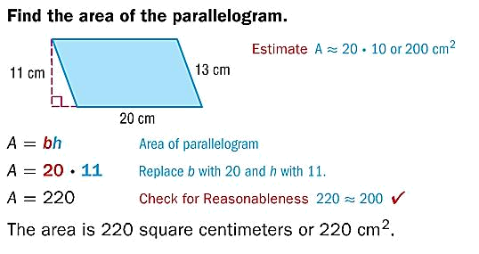
Area of Parallelograms
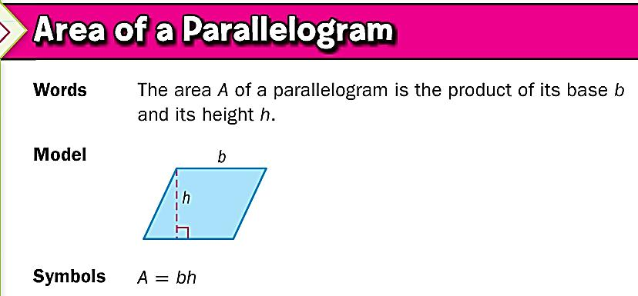

You Try:
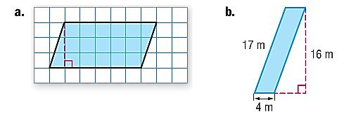

a) |  | b)
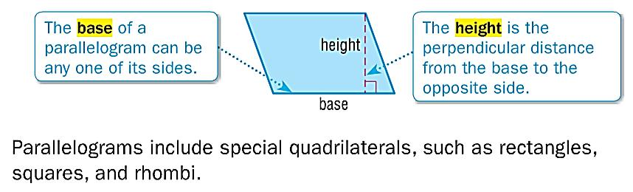

Examples:
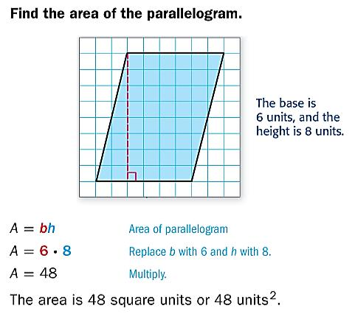

c) |  | d)
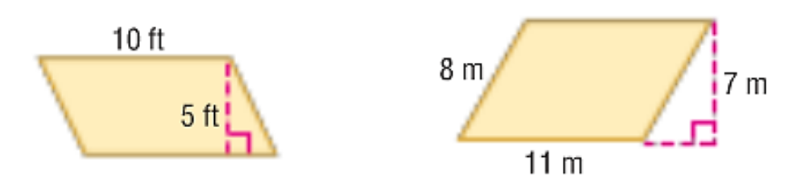

Pg.7a pg. 7b

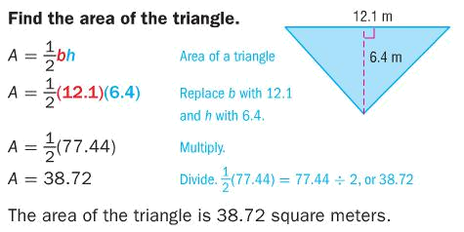
Area of Triangles
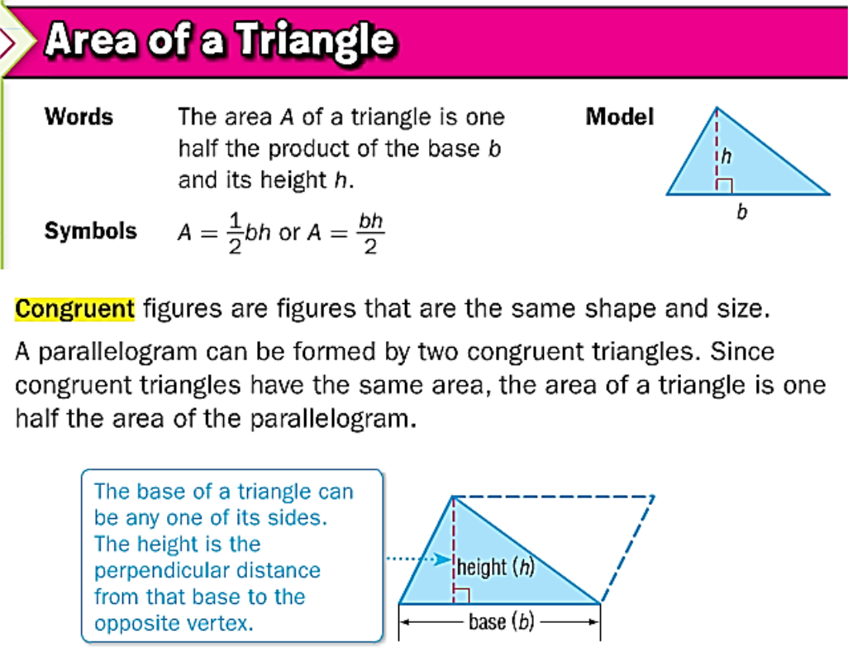

You Try:
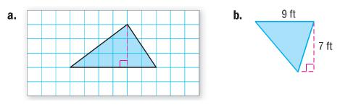

a) |  | b)

Examples:
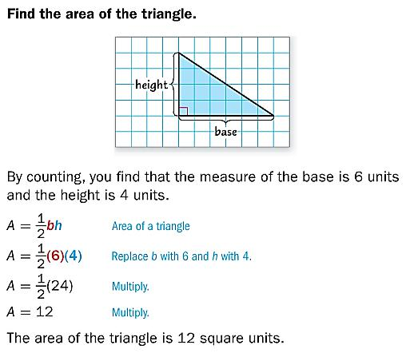

c) d) e)
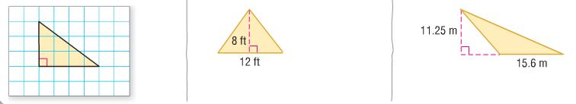

Pg.8a pg. 8b

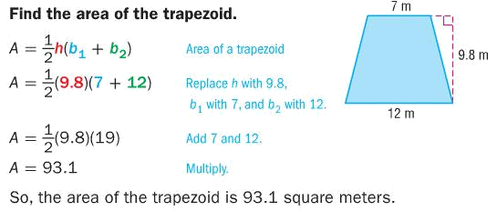
Area of Trapezoids
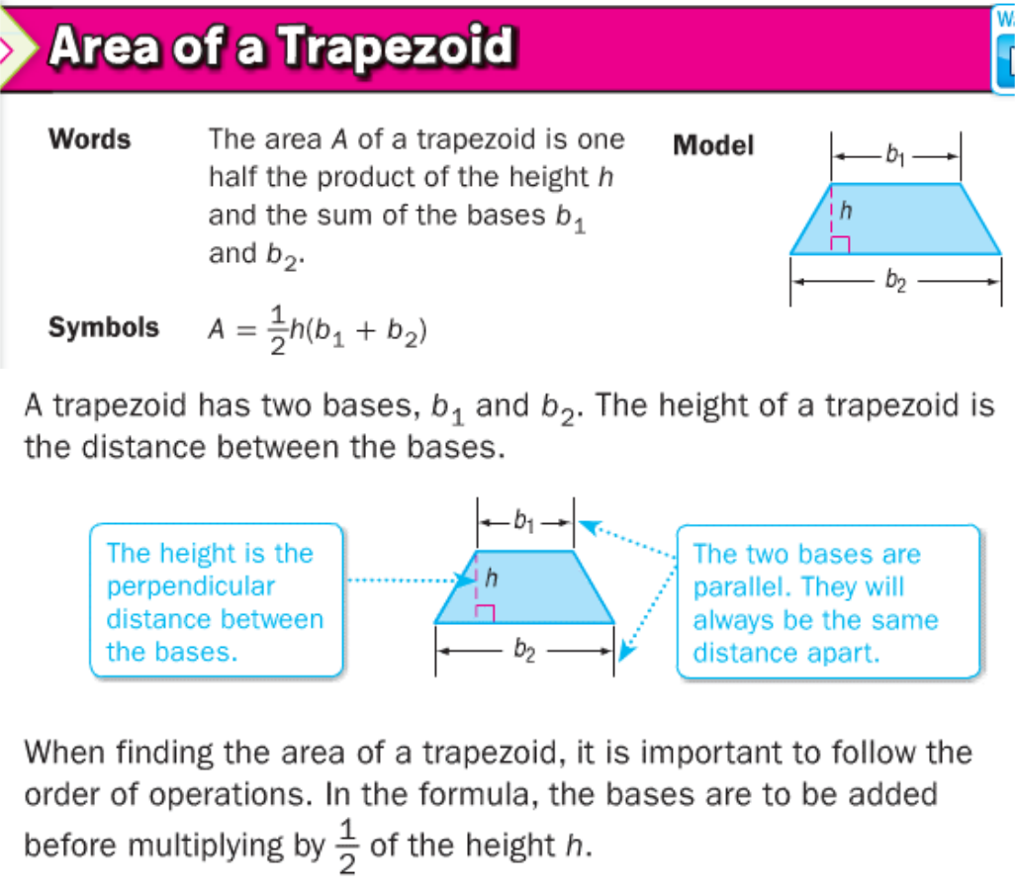

You Try:
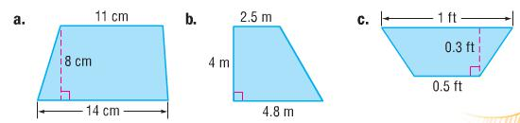

You Try:
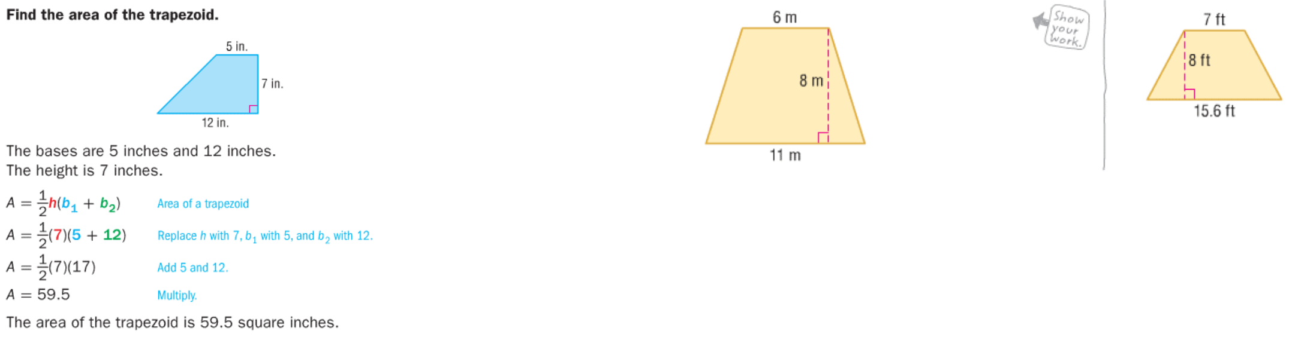

d) e)

Pg.9a pg. 9b

Area of Triangles and Quadrilaterals

Area is the amount of space INSIDE a figure. It is always measured in square units.

 |  |  |  | Triangle |  |  |  |  |  |  |  |  | Quadrilateral
 |  |  | = |  | 1 | • ℎ |  |  |  |  | = • or = • ℎ
 |  |  |  |  | 2
 |  |  |  | B = Base |  |  |  |  |  |  |  |  |  | L = Length
 |  |  |  | H = Height
 |  |  |  |  |  |  |  |  |  |  |  |  |  | W = Width
 | Example: |  |  |  |  |  |  |  |  |  | Example:
 | What is the area of the triangle? |  |  |  |  |  |  |  |  |  | What is the area of the rectangle?
 | h = height = 12 m |  |  |  |  |  |  |  |  |  | l = length = 8cm
 | b = base = 20 m |  |  |  |  |  |  |  |  |  | w = width = 3 cm
 | A = ½bh = ½ • 20 •12 = 120 m2 |  |  |  |  |  |  |  |  |  | A = lw = 8 • 3 = 24 cm2
 | Note: A triangle is half of a rectangle. That is why the area of
 | a triangle is half the area of a rectangle.
You Try:
 |  | Triangle |  |  |  |  |  |  | Square |  |  |  |  |  | Rectangle
 |  | h = 6ft |  |  |  |  |  |  | side = 8in |  |  |  |  |  | l = 9cm
 |  | b = 5ft |  |  |  |  |  |  |  |  |  |  |  |  | w = 3cm
 | Formula: _________ |  |  |  |  |  |  | Formula: _________ |  |  |  |  |  |  | Formula: _________
 | Area: ____________ |  |  |  |  |  |  | Area: ____________ |  |  |  |  |  |  | Area: ____________
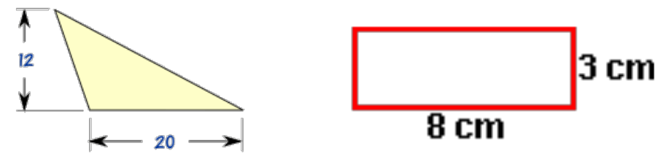
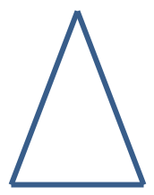
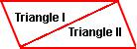

 | How do you calculate area? |  |  |  |  |  | Formulas for Area
Area is the _______________ of |  |  |  |  |  | Square:
____________ units needed to fill a
_____________________. Or, the amount |  |  |  |  |  | Rectangle:
of ___________________ in a polygon.
To calculate area, you must
 |  |  |  |  |  | Triangle:
________________ all the _______________.
Area is always measured in
______________________________________.
You Try:
1) When calculating |  |  | 2) What is the area of |  |  | 3) What is the area of
area, you can count |  |  | this shape? |  |  | this shape?
the square units in a
polygon.
How many square units
are there?
4) You can also use |  |  | 5) What is the area of |  |  | 6) What is the area of
the formulas above to |  |  | this shape? |  |  | this shape?
calculate the area of
shapes.
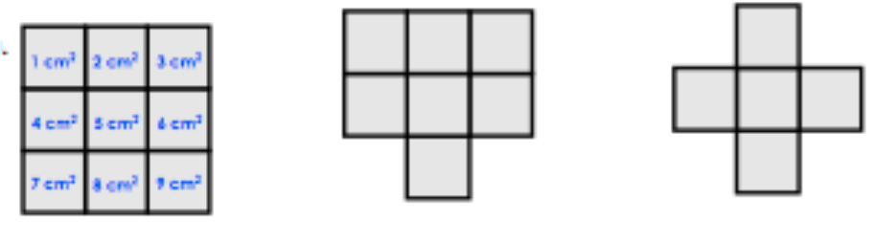
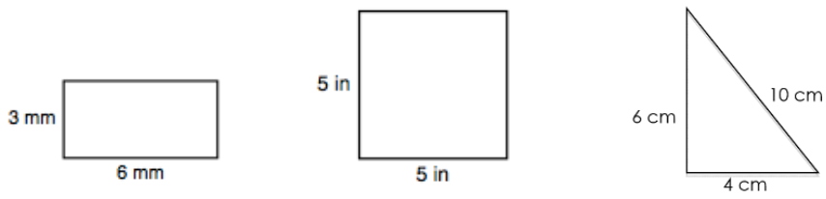

Pg.10a pg. 10b

Additional Practice with Area Area of Composite Figures

Name of | Polygon
Picture
Write the | formula
the variables | work)
Substitute for | (Show
Solve. Include square | units in your answer.
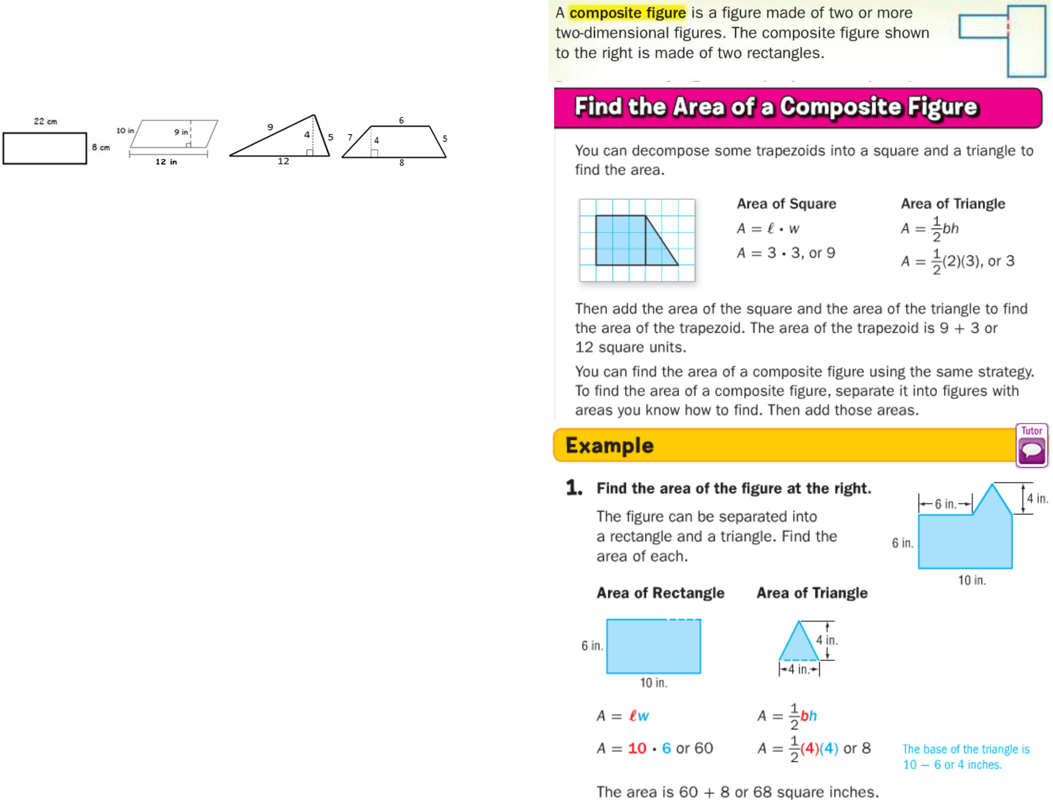

Pg.11a pg. 11b

The figure below is a composite figure. How would you find its area?

 | The house is made up of two
1 | shapes that you are familiar
1 | with – a triangle and a
 | rectangle. You can
 | “decompose” or “take
2 | apart” the figure to find the
2 | area of each piece and then
 | find the sum of those areas to
 | get the total area.
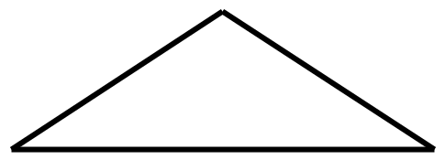

Try This:

Find the area of the rocket figure below.
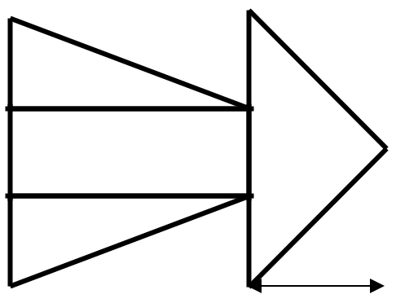
You Try:

Find the area of each composite figure. Remember to show all work! (Hint: Often, you will have to draw in lines to decompose the figure. Pay careful attention to the side lengths that are given so you can figure out the side lengths that are missing!)

- 3 cm

14 cm
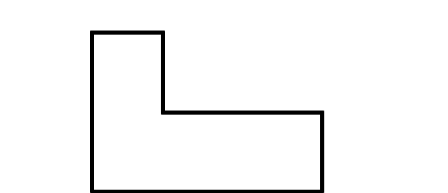

7 cm


8 cm

4ft

6ft ^{16ft} 14ft

4ft

5ft

- How many shapes can this figure be broken into?

- What two different types of shapes can you see?

- Determine the area of each shape.

14 in
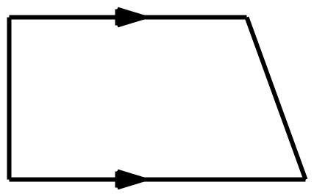

2)

12 in

22 in

10 m
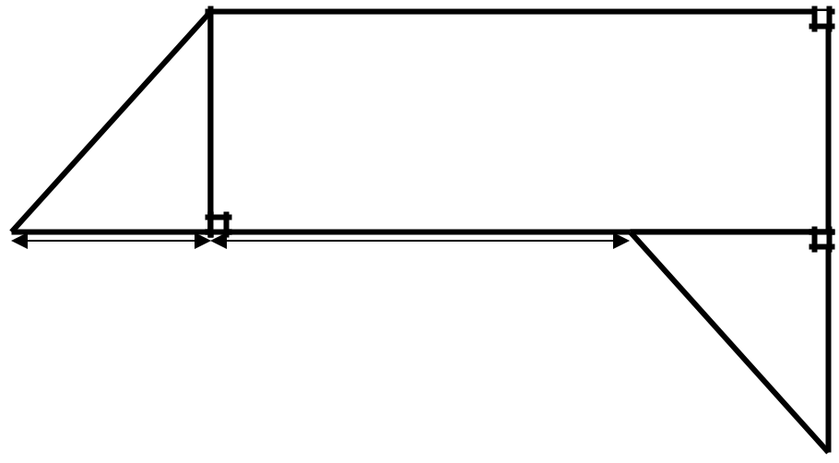

Shape | Shape #1 | Shape #2 | Shape #3 | Shape #4
Formula | Area△ = ½bh
Work | ½ • 16 • 4
Work | 8 • 4
Solution | 32 ft2

Lastly, add the area of each piece. Total Area =

3)

3 m

2 m 6 m

3 m

Pg.12a pg. 12b

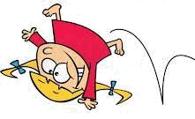
Area Error Analysis

Fill in the Flow Map with the 3 steps to solving problems on area:
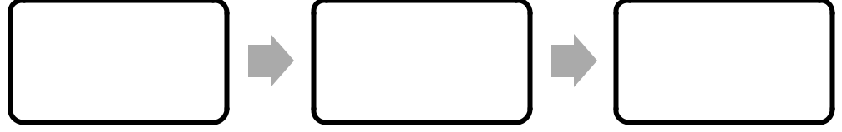

Silly Sally has struck again! Analyze her work in Column #1, and circle her mistake. In Column #2, explain what she did wrong. In Column #3, work out the problems correctly, showing ALL work!

Silly Sally’s Work | What did Silly | Show Silly Sally
Silly Sally’s Work | Sally do | how it’s done!
(Circle her mistake): | Sally do | how it’s done!
(Circle her mistake): | wrong? | (Show ALL steps!)

 | A = lw
8 m | A = lw
 | 12 • 8
12 m | 12 • 8
12 m | 20 m²

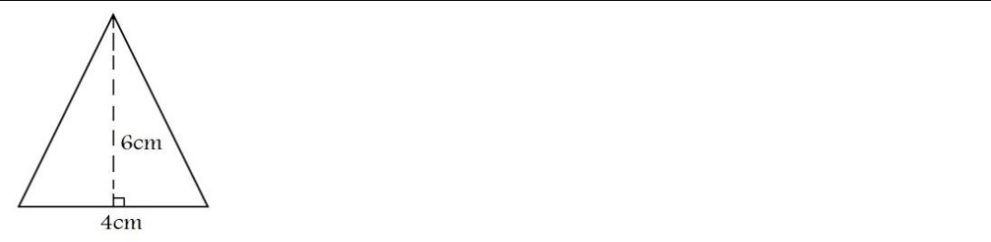

A = ½ b h
- • 4 • 6
24 cm²
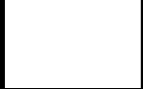
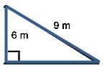

- = ½ b h
  - • 8 • 9
    - • 72
8 m 36 m²

Pg.13a
Find the area of each composite figure:
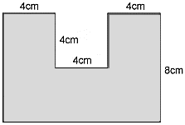

1) 2)
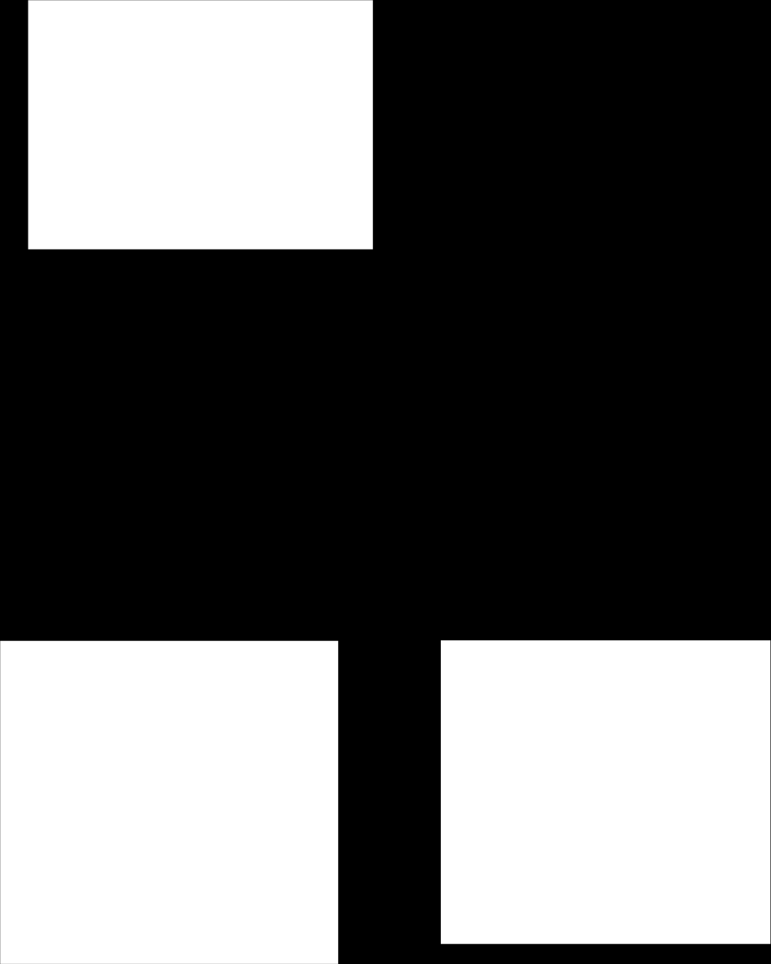
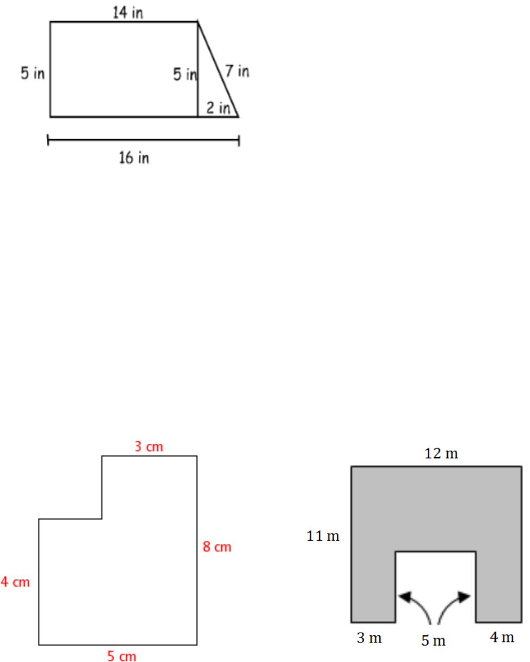

3) 4)

pg. 13b
More Area Practice with Composite Figures Nets
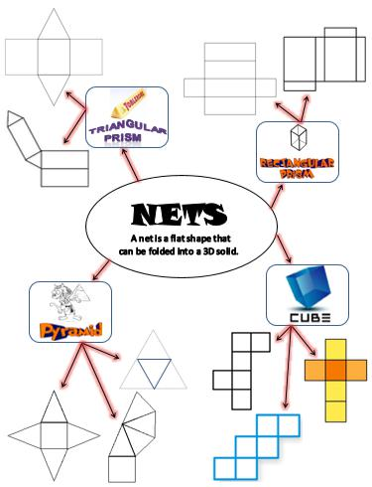

1) Find the area of the figure. 2)
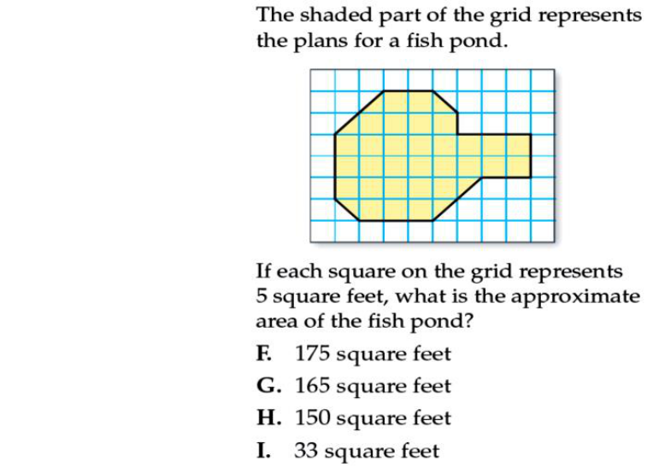

8 in

 | 4 in
 | 3 in |  |  | 6 in
4 in |  |  | 3 in
 |  |  | 2 in
 | 8 in
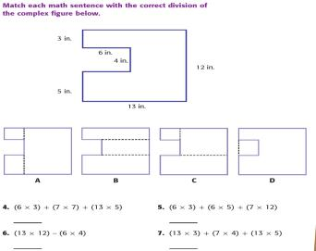


3)

Pg.14a pg. 14b

Nets of 3-Dimensional Figures Matching Nets and 3-D Figures
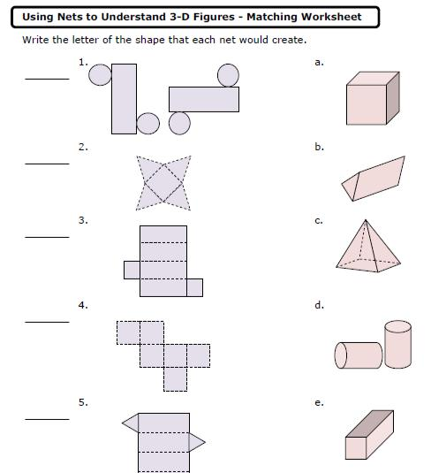

Face is a flat _____________________ of a solid figure.

Edge is a ____________________ segment where two faces of a
____________________ meet.

Vertex is a ____________________ where ____________________ or more edges of a solid figure meet or the pointed end of a cone opposite of its base.

FIGURE | FACES Look | BASE | How many | NET
 | Like |  | faces?
Cube
Rectangular
Prism
Triangular
Prism
Square
Pyramid
Triangular
Pyramid
Cylinder
Cone
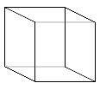
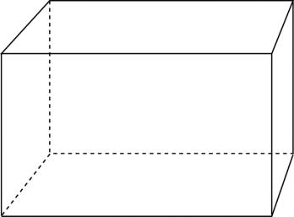
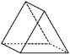
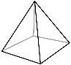
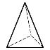
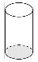
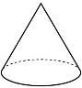

Pg.15a pg. 15b

Using Formulas to Find Surface Area

A formula is a mathematical rule using variables. It allows us to easily find a value such as area, volume, circumference, perimeter, etc. Formulas are used often in math and science!

Formulas for Surface Area:
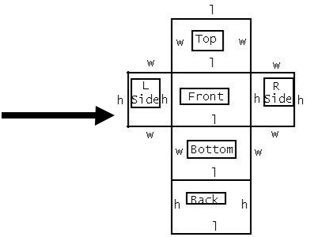

SA Rectangular Prism = 2(l•w) + 2(l•h) + 2(w•h)
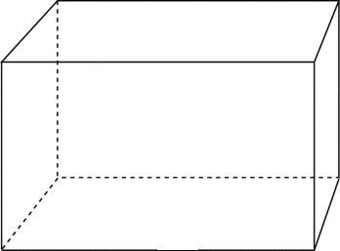

h

w
l

SA Cube = 6s²

s
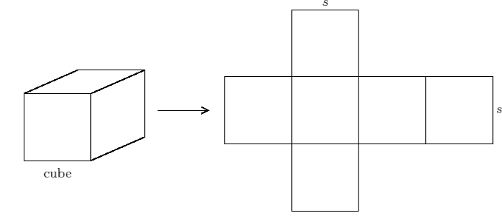

s
s
Using Formulas to Find Surface Area

So… what exactly IS surface area, anyway?
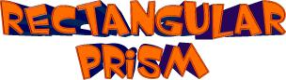

Draw a rectangular prism: | Draw the net of a rectangular prism:
How do you think you could calculate the SURFACE AREA of a RECTANGULAR PRISM?


Draw a SQARE PYRAMID: | Draw the net of a SQARE PYRAMID:

How do you think you could calculate the SURFACE AREA of a SQARE PYRAMID?

Pg.16a pg. 16b

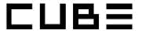

Draw a CUBE: | Draw the net of a CUBE:
How do you think you could calculate the SURFACE AREA of a CUBE?

Complete the following statement:

When I need to find the surface area of a 3-dimensional (3-D) figure, I can do that by…

You Try:

Using either method (nets or formulas), find the surface area.

1)
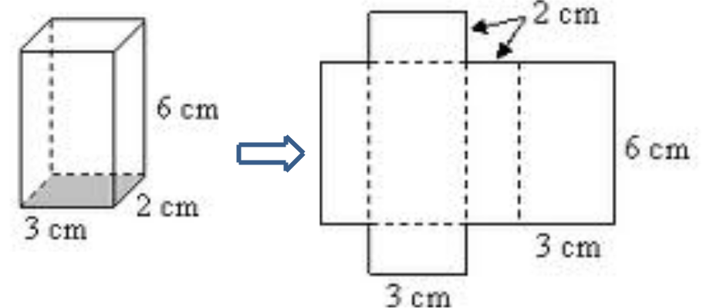

2) 3)
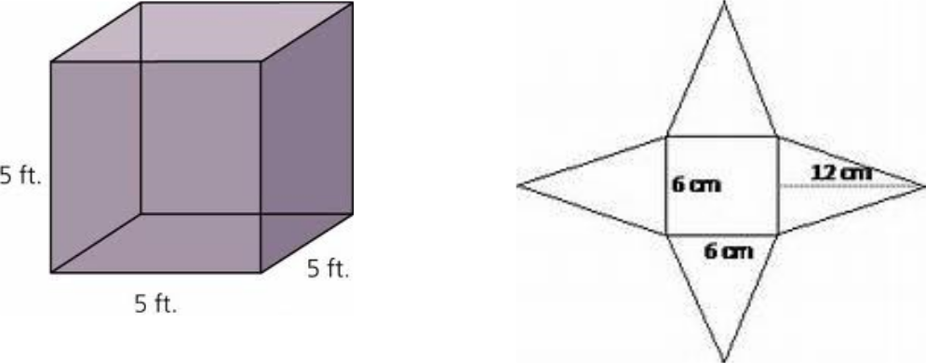

Pg.17a pg. 17b

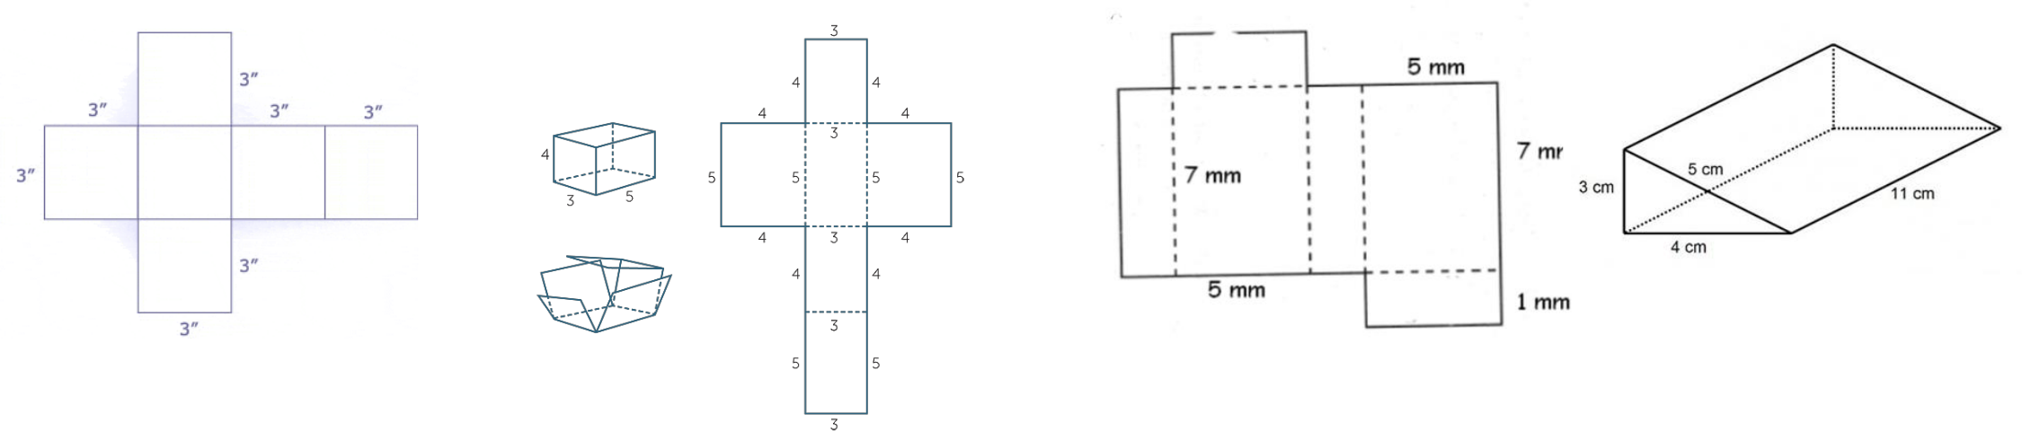
4) 5) 8) 9)
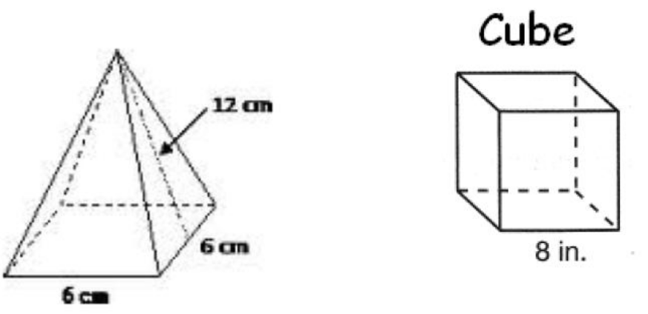

10) 11)
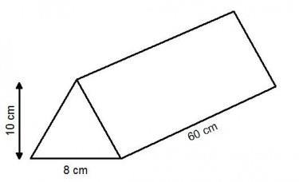

6) 7) Find the Surface Area of a cube with side length 4cm.

Pg.18a pg. 18b

Surface Area in the Real World

Solve each of the problems by drawing a net and finding the surface area.

- A pizza box is 15 inches wide, 14 inches long, and 2 inches tall. How many square inches of cardboard were used to create the box?
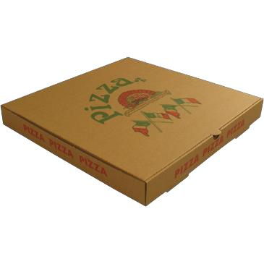

2) What is the surface area of a Rubik’s Cube that is 6 cm tall?
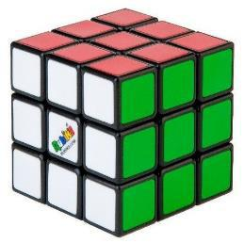

- Angelo is making a replica of an Egyptian pyramid. He is making a square pyramid with a base that is 3 feet long and 3 feet wide. The triangular sides of the pyramid each have a height of 14 feet. How much material will Angelo need to cover the pyramid?
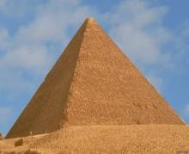
- Sydney is painting a rectangular toy box for her little brother. She will paint all 4 sides and the top (she will NOT paint the bottom). If the toy box is 20 inches tall, 12 inches wide, and 25 inches long, how many square inches will she need to paint?
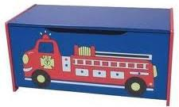

- DeAndre is making a tent for his hamster. It is 20 cm long, and the triangular bases are 15 cm high and 10 cm wide (see picture below). How much material will he need to make the tent?
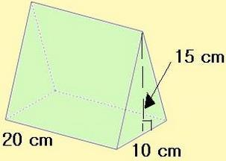

20 cm

Pg.19a pg. 19b

Volume of Rectangular Prisms

Volume is the amount of space inside a 3D object, measured in cubic units.
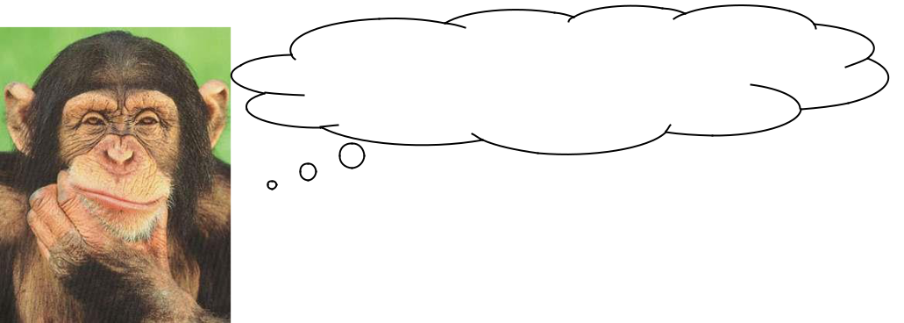

Ever wonder WHY volume is measured in cubic units??

Since volume measures the amount of space INSIDE a figure, it’s like you’re packing the figure with little tiny cubes!!
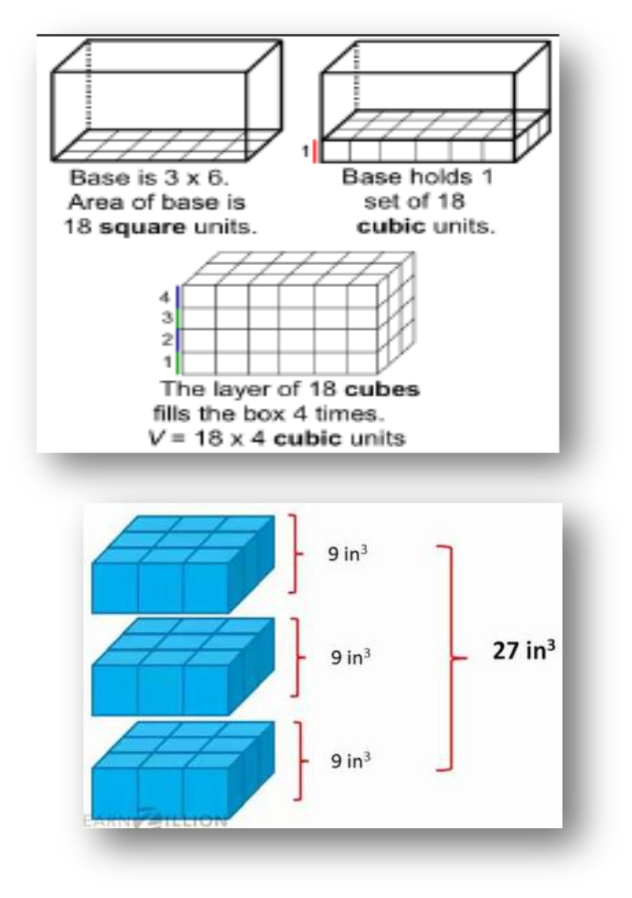

Here’s a visual of

- rectangular prism being packed with unit cubes…

72 Cubic Units

Here’s a visual of a cube being packed with unit cubes…
Volume is the _________________ of __________________ units needed to fill the space in a three dimensional (3D) figure.
Volume is always measured in cubic units.

We calculate volume you must find the area of the ____________

then multiply it by the _____________________.
This can be written as __________ • __________.
OR __________ • __________ • __________ for a rectangular prism.

Example:

Find the volume of the rectangular prism below.
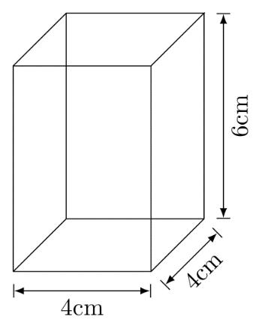
V = B • h
V = l • w • h
V = 4 • 4 • 6

V = 96 cm3

You Try:

Find the volume.
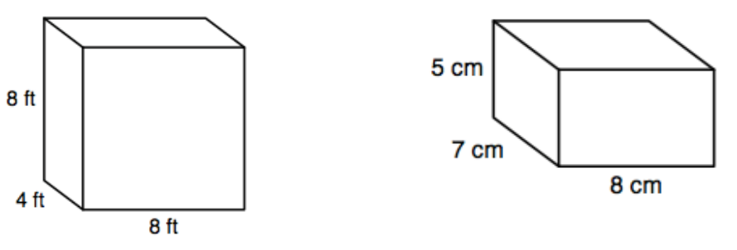

1) 2)

Pg.20a pg. 20b

3) |  | 4)
5) | Find the volume of a | 6) | Find the volume of a
 | rectangular prism with B = |  | rectangular prism with l =
 | 78ft2 and h = 23 ft. |  | 4.2cm, w = 3.8cm, and h =
 |  |  | 6cm.
7) | Find the volume of a | 8) | Find the missing dimension of
 | rectangular prism with l = 8 ¼ |  | the rectangular prism.
 | in., w = 9in and h = 15in. | L = 14 cm
 |  | W = ?
 |  | H = 3 cm
 |  | V = 294 cm
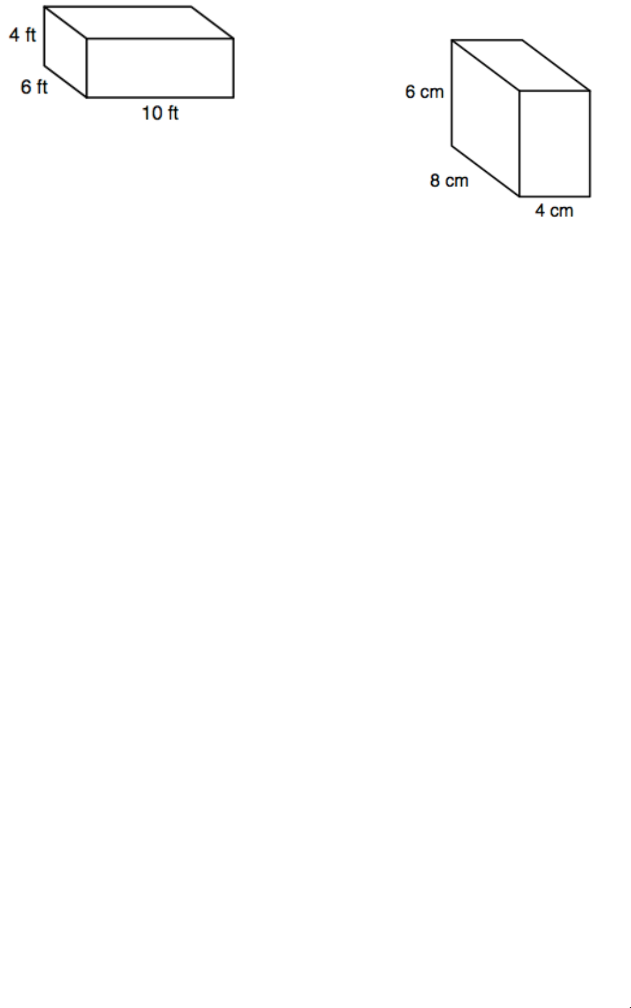

Volume of Rectangular Prisms with Fractional Edges
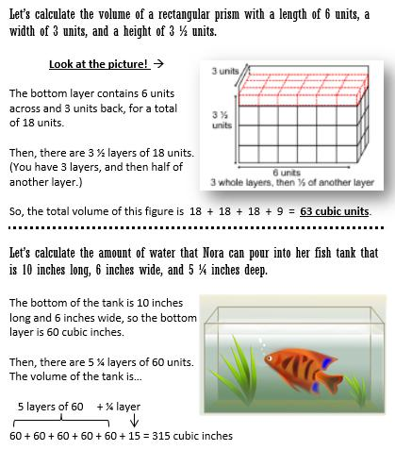

You Try:

Find the volume of a rectangular prism with a length of 3cm, a width of 2 ½ cm, and a height of 4 cm.

Pg.21a pg. 21b

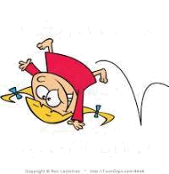
Volume Error Analysis

Sally is a silly little girl that makes silly mistakes! CHOOSE ANY 4 PROBLEMS BELOW. Analyze her work in Column #1, and circle her mistake. In Column #2, explain what she did wrong. In Column #3, show how Silly Sally should work out the problem. Show ALL work!
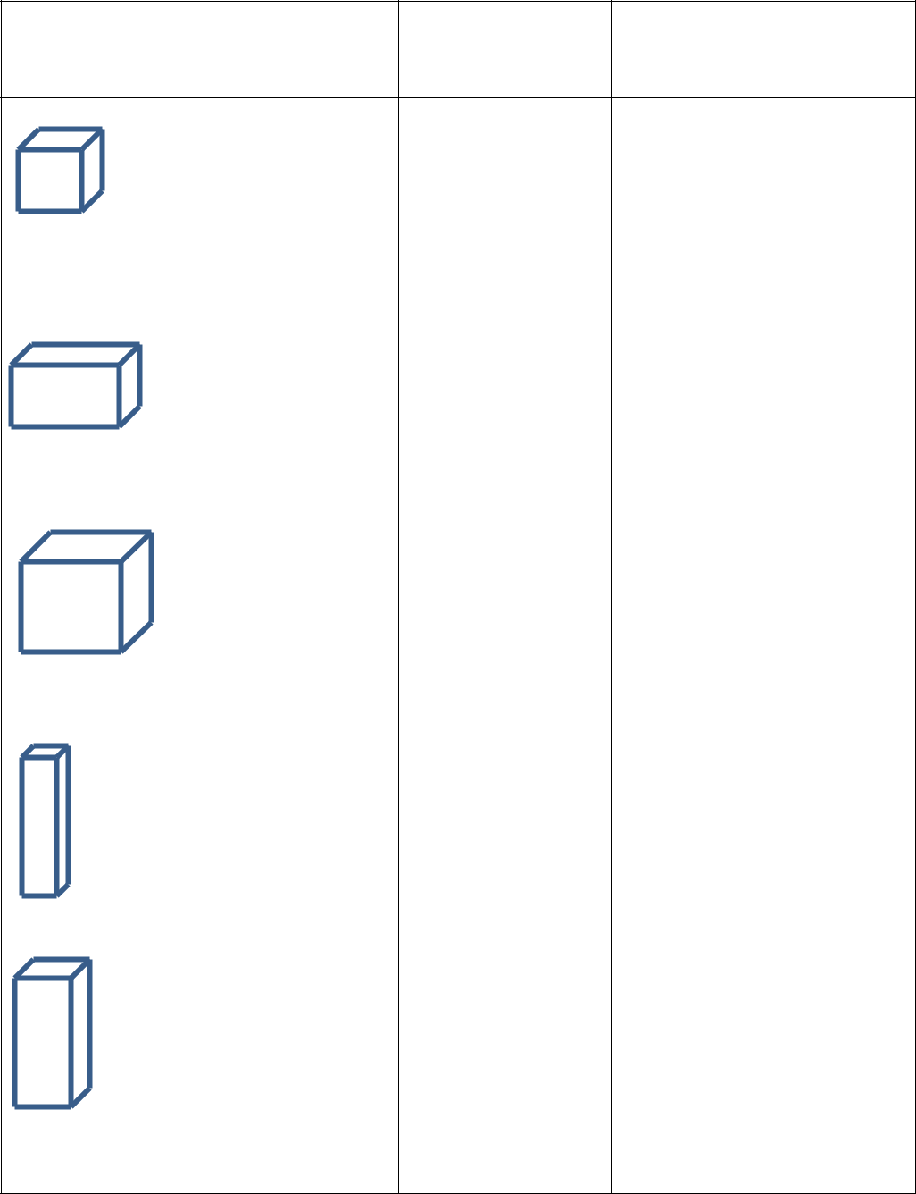
Silly Sally’s Work | What did Silly | Show Silly Sally how it’s
Silly Sally’s Work | What did Silly | done!
(Circle her mistake): | Sally do wrong? | done!
(Circle her mistake): | Sally do wrong? | (Show ALL steps!)

- = l w h

V = 4 • 4 • 4
4m |  |  |  |  |  |  | V= 12 m³
 |  |  |  |  |  |  | 2mm |  |  | V = l w h
 |  |  |  |  |  |  |  |  |  | V = 8 • ½ • 2
 |  |  |  |  |  |  | 1 | mm |  | V = 4 • 2
8mm |  |  |  |  |  |  | 2
8mm |  |  |  |  |  |  | 2 |  |  | V = 8mm2
 |  |  |  |  |  |  |  |  |  | V = l w h
 |  |  |  |  |  |  |  |  |  | V = |  |  |  |  |  |  |  |  |  | 2 |  |  | ∙ | 2 |  |  |  |  | ∙ | 2
 |  |  |  |  |  |  |  |  |  |  |  |  |  |  |  | 3 |  |  |  |  |  |  | ∙ | 3 |  |  |  |  | ∙ | 3
 |  |  |  |  |  |  |  |  |  | V = |  |  |  |  |  |  |  | 6 |  |  | = |  |  |  |  | 2 |  | in3
Cube = 2/3 in. tall |  |  |  |  |  |  |  |  |  |  |  |  |  |  |  | 9 |  |  |  |  |  |  |  | 3
 |  |  |  |  |  |  |  |  | V = l w h
8 ¼ yd |  |  |  |  |  |  |  |  | V = 8 ¼ • 2 ½ • 3
 |  |  |  |  |  |  |  |  | V = 16 |  |  |  |  | 1 | • 3
 |  |  |  |  |  |  |  |  |  |  |  |  |  | 8
 |  |  |  |  |  |  |  |  | V = 48 |  |  |  |  | 1 | yd3
_{3 yd} 2 ½ yd |  |  |  |  |  |  |  |  |  |  |  |  |  | 8
 | 8 |  |  | 1 |  | yd |  |  | V = l w h
 |  |  |  |  |  |  |  |  | V = 4 ½ • 1 ½ • 2
 | 4
 |  |  |  |  |  |  |  |  | V = |  | 8 |  | • |  |  | 3 |  |  | • 2
1 |  | 1 |  |  | yd |  |  |  | V = | 2 |  |  |  |  |  | 2
1 |  | 1 |  |  |  |  |  |  |  |  | 24
1 |  | 2 |  |  |  |  |  |  | V = |  |  |  |  | • 2
2 yd |  |  |  |  |  |  |  |  | V = | 4

V = 12 yd3
More Volume Practice

Determine the Volume of each rectangular prism or cube below. Include units and show your work!

- A cube that is 12 yards wide

- The box with dimensions of 6 ft • 4 ft • 1 ½ ft

- Determine the Volume of a rectangular truck bed that is 12 feet long, 5 ¼ feet wide, and 3 feet deep.

- How much water can be poured into a cubic tank that is 2 ½ feet long?

- What is the volume of a gift box that is 3 ½ inches wide, 2 inches tall, and 6 inches long?

Pg.22a pg. 22b

