NAME:_____________

Unit 2

Rate, Ratio and Proportional Reasoning

Ratios

Unit Rate

Proportions

Percents

Measurement Conversion

Pg.1a

Unit 2: Rate, Ratio and Proportional Reasoning Standards, Checklist and Concept Map
Georgia Standards of Excellence (GSE):

MGSE6.RP.1: Understand the concept of a ratio and use ratio language to describe a ratio between two quantities. For example, “The ratio of wings to beaks in the bird house at the zoo was 2:1, because for every 2 wings there was 1 beak.” “For every vote Candidate A received, Candidate C received nearly 3 votes.”

MGSE6.RP.2: Understand the concept of a unit rate a/b associated with a ratio a:b with b ≠ 0, and use rate language in the context of a ratio relationship. For example, “This recipe has a ratio of 3 cups of flour to 4 cups of sugar, so there is ¾ cup of flour for each cup of sugar.”

MGSE6.RP.3b: Solve unit rate problems including those involving unit pricing and constant speed. For example, if it took 7 hours to mow 4 lawns, at that rate, how many lawns could be mowed in 35 hours?

MGSE6.RP.3 : Use ratio and rate reasoning to solve real-world mathematical problems, e.g., by reasoning about tables of equivalent ratios, tape diagrams, double number line diagrams, or equations.

MGSE6.RP.3a : Make tables of equivalent ratios relating quantities with whole-number measurements, find missing values in tables, and plot the pairs of values on the coordinate plane. Use tables to compare ratios.

MGSE6.RP.3c : Find a percent of a quantity as a rate per 100 (e.g., 30% of a quantity means 30/100 times the quantity); solve problems involving finding the whole, given a part and the percent.

MGSE6.RP.3d : Use ratio and rate reasoning to convert measurement units; manipulate and transform units appropriately when multiplying or dividing quantities.

What Will I Need to Learn??

________ I can understand ratios
________ I can understand unit rates

________ I can solve unit rate problems

________ I can make tables of equivalent ratios, find missing values, and plot points in a coordinate plane; compare ratios in a table

________ I can solve problems with tables, tape or number line diagrams, or equations

________ I can find percent of a number
________ I can find the whole when given part and %

________ I can convert Metric units
________ I can convert Customary units

pg. 1b

 | Unit 2 - Vocabulary
Term |  |  | Definition
Customary System |  |  | The primary system of measurement used in
 |  |  | the US, which uses a variety of conversions
Double Number |  |  | A visual model used to solve unit rate
Line Diagram |  |  | problems and proportions
Metric System |  |  | The system of measurement that uses a base-
Metric System |  |  | 10 model; used by most countries
Percent |  |  | Number out of 100
Proportion |  |  | An equation of equivalent ratios
Rate |  |  | A ratio that compares quantities measured in
Rate |  |  | different units
Ratio |  |  | A comparison of two numbers
Unit Rate |  |  | A comparison of two measurements in which
Unit Rate |  |  | one of the terms has a value of 1
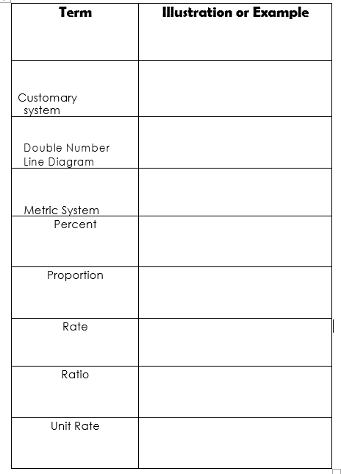

Pg.2a pg. 2b

Ratios

A __________ is a comparison of two quantities by division.

The ratio of two red paper clips to six blue paperclips can be written in the following ways:
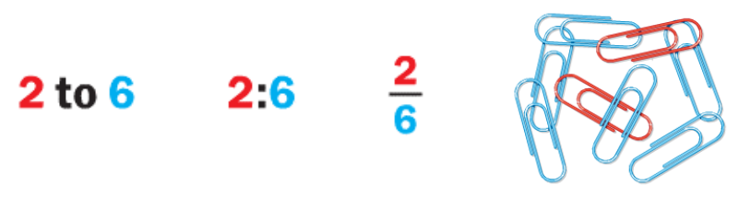

Just like fractions, we usually represent a ratio in simplest form.

ORDER MATTERS!
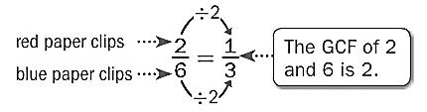

Example:

Several students named their favorite flavor of gum. Write the ratio that compares the number of students who chose fruit to the total number of students.
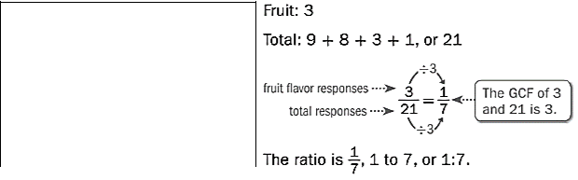

Favorite Pets
 | Flavor |  |  |  | # of
 |  |  |  | Responses
Peppermint |  |  |  | 10
Cinnamon |  |  |  | 6
 | Fruit |  |  | 8
Spearmint |  |  |  | 1

So, 1 out of every 7 students preferred fruit-flavored gum.
You Try:

Use the stars to answer questions 1 and 2.


- Write the ratio of black stars to white stars in three different ways.

_______________ _______________ _______________

- Write the ratio of white stars to black stars in three different ways.

_______________ _______________ _______________

Use the table below to answer questions 3-6.
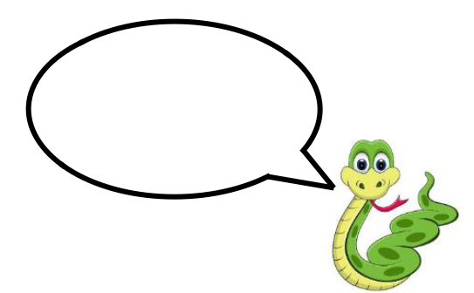

Favorite Pets
 |  |  | Pleasssssssssse
Snake |  | 15 | Pleasssssssssse
 |  |  | remember to
Dog |  | 10 | remember to
Dog |  | 10 | sssssssssimplify!
Cat |  | 6 | sssssssssimplify!
Hamster |  | 8
Fish |  | 1

- What is the ratio of people who chose snakes as their favorite pet to those who chose dogs?

- What is the ratio of people who chose cats AND dogs to those who chose hamsters?

- What is the ratio of those who chose snakes as their favorite pet to everyone that was surveyed?

- What is the ratio of those who chose cats to those who chose fish?

Pg.3a pg. 3b

Pg.3b
Use the words, “Barber Middle School” to answer questions 7-11.

- What is the ratio of vowels to consonants?

- What is the ratio of letters in BMS to Barber Middle School?

- What is the ratio of the letters in “Barber” to the letters in “Middle School”?

- What is the ratio of the letters in “Middle School” to the letters in “Barber”?

- Crain says the ratio of letters in “Middle” to “Barber” is 6:6.

Hailey says that ratio is 1:1. Who is correct? Explain your answer.

The table below shows the number of balloons purchased in each color at Party City. Using this information, answer questions 12-15.

Color | Red | Yellow | Blue | Green
Quantity | 10 | 20 | 15 | 25
Sold

- Which two items does the ratio 10:20 represent?

- Which two items does the ratio 3:5 represent?

- Which two items does the ratio 5 to 3 represent?
- Which two items does the ratio ³₂ represent?

- Which two items does the ratio 4:3 represent?

Different Types of Ratios

Part to __________ ratios are ratios that relate one part of a whole to another part of a whole.

Example:

There are 4 boys for every 6 girls. The ratio of boys (a part of the group of kids) to girls (another part of the group of kids) is 4:6 (simplified to 2:3).

You Try:


Boys:


Girls:

The ratio of boys to girls is: __________ to __________

The ratio of girls to boys is: __________ : __________

Part to __________ ratios are ratios that relate one part of the whole to the whole.

Example:

There are 4 boys (a part of the group of children) for every 10 children (the whole group of children), written as 4:10 (simplified to 2:5). On the other hand, 6 girls for every 10 children is written as 6:10 (simplified to 3:5).

You Try:


Boys:


Girls:

The ratio of boys to children is: __________ to __________

The ratio of girls to children is: __________ : __________

Pg.4a

Pg.4b
NAME THE RATIO

write a sentence to describe a ratio relationship between two quantities. | Name the ratio using math symbols | Identify the type of ratio
1.

2.

3.

4.

5.

6.

7.

8.

9.

10.

11.

12.

Pg.5b

pg. 5a
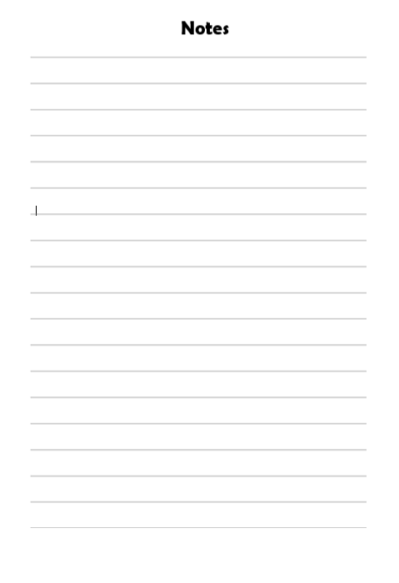

Pg.6a Pg.6b

More Practice with Ratios

Use the table to answer the following questions.

Favorite Snacks of the 6th Graders

Ice Cream | 12
Takis | 6
Candy | 9
Fruit | 4
Sunflower Seeds | 2
Seaweed | 5
Cookies | 7

Find the following ratios. Don’t forget to simplify if necessary.

- candy to seaweed __________ to __________

- sunflower seeds to cookies __________ to __________

- Takis to ice cream __________ to __________

- candy to cookies and fruit __________ to __________

- cookies to Takis __________ to __________

- fruit to candy __________ to __________

- Takis and fruit to seaweed __________ to __________

- ice cream to sunflower seeds __________ to __________

- candy to total __________ to __________

- cookies and ice cream to total __________ to __________
Ratio Tables

A __________ __________ is a table of values that displays equivalent ratios.

Example:
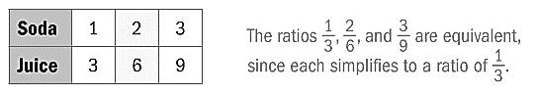

Equivalent ratios express the same relationship between quantities. In the example above, for every 1 soda, there are 3 juices.

Examples:

- To make yellow icing, you mix 6 drops of yellow food coloring with 1 cup of white icing. How much yellow food coloring should you mix with 5 cups of white icing to get the same shade?
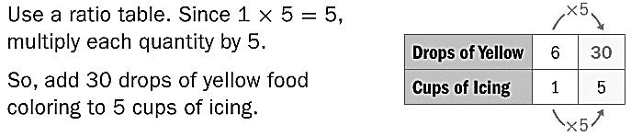

- In a recent year, Joey Chestnut won a hot dog eating contest by eating nearly 66 hot dogs in 12 minutes. If he ate at a constant rate, determine about how many hot dogs he ate every two minutes.
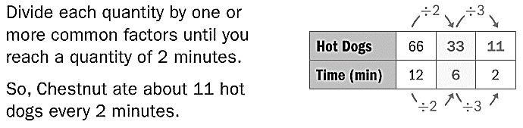

Pg.7a pg. 7b

More Practice with Ratio Tables

Find the missing values to complete the ratio tables.

1) | 2 |  | 6 | 10
 | 4 | 8
2)
2) |  |  | 3
 | 7 | 14 | 21 | 28
3)
3) | 8 | 40 |  | 48
 | 5 | 10 | 25 | 30
4)
4) | 2 | 6 | 8 | 10
 | 5
5)
5) | 3 | 9 | 21 | 27
 |  |  |  | 36
6)
6) | 4 |  | 12 | 16
 | 6 | 12
7)
7) | 11 |  | 33 | 44
 | 15 | 30
8)
8) | 5 |  | 15
 | 12 | 24 |  | 48
More Practice with Ratio Tables

Find the missing values to complete the ratio tables.

9) | 1 |  | 2 | 3 | 4
 | 2
10)
10) |  | 2 | 4 | 6 | 8
 |  | 3
11)
11) |  | 1 |  | 3 | 6
 |  | 7 | 14
12)
12) |  |  |  | 3
 |  | 9 | 18 | 27 | 36
13)
13) |  | 10 |  | 30 | 40
 |  | 15 | 30
14)
14) |  | 3 |  | 9
 |  | 12 | 24 |  | 48
15)
15) |  | 8 | 16 | 24 | 32
 |  |  |  |  | 36
16)
16) |  | 15 |  | 45 | 60
 |  | 16 | 32

Pg.8a pg. 8b

Unit Rates
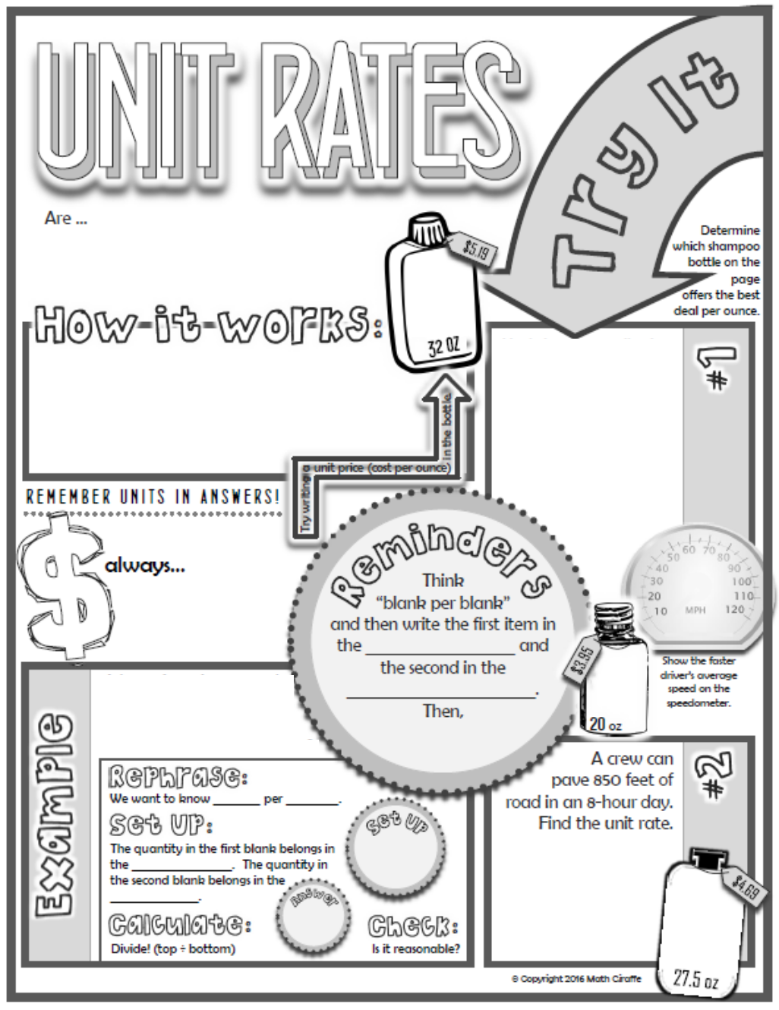

Karl drove 400 miles in
5 hours. Teresa drove
360 miles in 4 hours.
How had the higher

average speed?

A box of 100 hexagonal floor
tiles covers 250 square feet
of floor. How much area
does a single tile cover?
Unit Rates

 | What two rates are being | Find the unit rate. Show your
 | compared? | work!
Jay drove 360 miles on
24 gallons of gas.
 | What two rates are being | Find the unit rate. Show
 | compared? | your work!
Maya drove 540 miles
on 30 gallons of gas.
 | What two rates are being | Find the unit rate. Show
 | compared? | your work!
1452 calories in a 12-
slice cake.
 | What two rates are being | Find the unit rate. Show
 | compared? | your work!
880 calories in an 8-
slice pie
 | What two rates are being | Find the unit rate. Show your
 | compared? | work!
15-oz Cheerios for $3.95
 | What two rates are being | Find the unit rate. Show
 | compared? | your work!
10-oz Cheerios for
$2.85
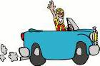
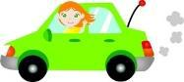
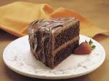
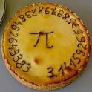
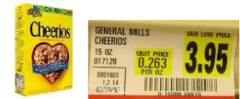
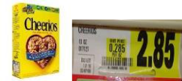

Pg.9a pg. 9b

Pg.10a

Pg.10b
Equivalent Ratios and Unit Rate

You can find a unit rate by setting up a proportion.

Example:

- There are 21 water bottles to 7 forks. Find the unit rate for 1 fork.

 |  |  | ÷ 7 |  |  | 
First, set up a proportion: |  | = | 21 |  | = | 
First, set up a proportion: |  | = | 7 |  | = | 1
÷ 7


You can look at the relationship that is created for the forks. The 7 was divided by 7 to make 1. Then apply that same relationship to the top. 21 divided by 7 is 3.

So, there are 3 water bottles for every 1 fork.

You Try:

- Megan paid $12.00 for 3 lip gloss flavors. What is the unit rate?

  - Erin paid $12.00 for 5 lip gloss flavors. What is the unit rate?
Equivalent Ratios

You can find equivalent ratios in two different ways, using a table or a graph.

Tables

- Fill in the information already given to you.

- Find the pattern by writing the numbers as a fraction.

- Fill in the rest of the table based on the pattern. (Multiply the top and bottom number by a common factor.)

Example:

1) Find the missing value by finding equivalent ratios.

× 5

Green | 2 |  |  |  |  | 4 |  |  |  | 6 |  |  |  | 8 |  | 10
Beads |  |  |  |  |  | 4 |  |  |  |  |  |  |  | 8 |  | 10
Blue | 5 |  |  |  |  | 10 |  |  |  | 15 |  |  |  | 20 |  | ?
Beads |  |  |  |  |  | 10 |  |  |  |  |  |  |  | 20 |  | ?
 |  |  |  |  |  |  | × 5
 | 2 |  |  | 4 |  |  | 6 |  |  | 9 |  |  |  | 10
 |  |  | = |  |  | = |  |  |  | = |  | =
 | 5 |  | = | 10 |  | = | 15 |  |  | = | 20 |  |  | ?

Since the pattern shows that we are multiplying the numerator and denominator of our original fraction by the same factor, you can see that we multiplied 2 times 5 to get 10. That means we will multiply 5 by 5, so the ? must be equal to 25.

Pg.11a pg. 11b

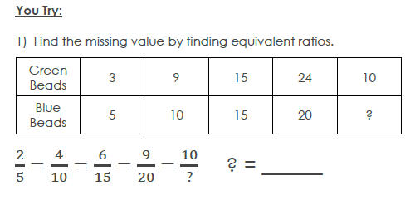

Graphs

- Plot the points that are already given to you.

- Draw a line to connect the points.

- Plot the rest of the points based on the pattern you see.

Example:

- To make rice, you need 1 cups of rice and 2 cups of water. Use the graph below to find out how many cups of

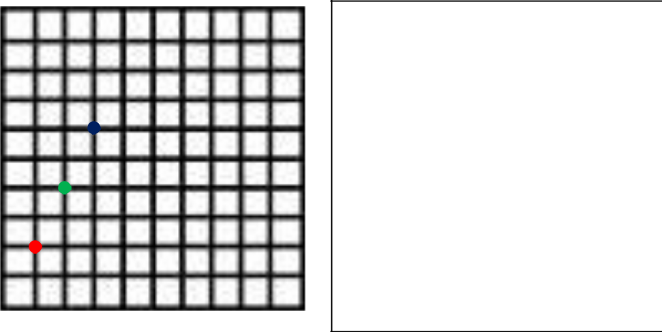
water you would need to make 3 cups of rice
Ordered Pairs:

( 1 , 2 )

( 2 , 4 )

( 3 , _____)

What pattern do you see? As you increase the rice by 1 cups, you must increase the water by 2 cups.
You Try

- Every 3 days, students in a fitness class run 2 miles. Use the graph below to determine how many miles they run in total over 9 days.

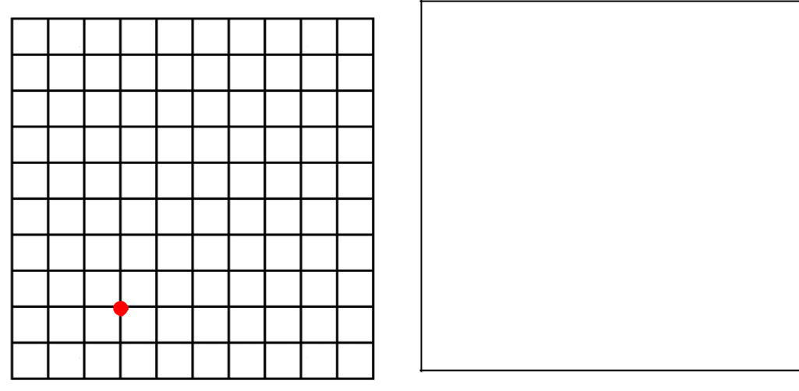

Ordered Pairs:

( 3 , 2 )

( _____ , _____ )

( _____ , _____ )

What pattern do you see?

They would run __________ miles total in 9 days.

- Use either method you have learned to answer the following question: There are 3 people in each row of seats on an airplane. How many people can be seated in 4 rows?

Using the graph above, can you tell how many cups of water you would need for 5 cups of rice?

Pg.12a Pg.12b

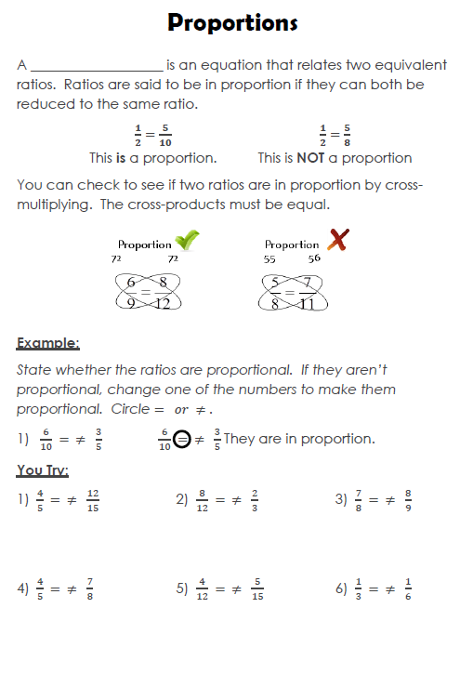
Pg.13a

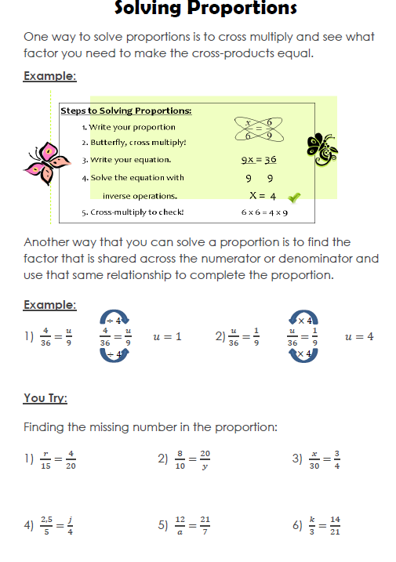
pg. 13b

You can set up proportions to solve word problems as well.

Example:

- Jazmine won a pie-eating contest, eating 6 pies in 10 minutes. At that rate, how many pies can she eat in two hours?
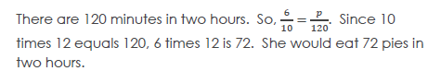

You Try:

- Matthew hiked 10 miles in 4 hours. At that rate, how far can he hike in 18 hours?

- A recipe calls for 2.5 cups of sugar to make 12 cookies. How much sugar is needed to make 36 cookies?

- If 16 necklaces can be bought for $40, how much will 12 necklaces cost?

- Sebastian can correctly solve 120 multiplication problems in 2 minutes. At this rate, how long would it take him to solve 300 problems?

- Alexandra types at a speed of 45 words per minute. How many words can she type in 10 minutes?

- Daisy needs 1.5 cups of sugar to make 12 cupcakes. How much sugar does she need to make 48 cupcakes?

Pg.14a pg. 14b

Finding the “Percent of” a Number
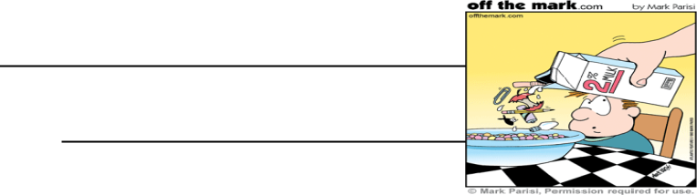

Percent means

In math “of” means

To find the “percent of” a number:

- Change the percent to a ____________________ and then

____________________.

- Turn the percent into a ____________________ and then

____________________.

100% means 1 whole. Therefore 100% of 85 is 85. That’s just like changing 100% to its equivalent decimal, 1, and multiplying by

- If you have less than 100% of a number, the solution is less than the original number.

Example:

Find 75% of 36.
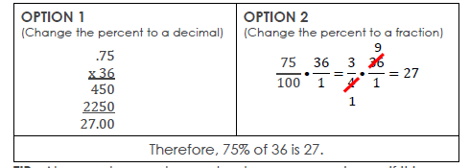



TIP: Always, always, always check your answer to see if it is reasonable. (Does it make sense?) 75% is less than 100% so 27 should be less than 36. 75% is greater than 50% so 27 should be greater than half of 36, which is 18. If those things are true, you are probably on the right track!

You Try:

For each problem below, circle the ONLY reasonable answer based on what you know.
Problem | Circle the ONLY reasonable answer
90% of 40 | 9 | 36 | 17 | 57
25% of 72 | 18 | 54 | 2.5 | 70
50% of 1600 | 56 | 16 | 1650 | 800
110% of 55 | 1.5 | 115 | 60.5 | 25
5% of 80 | 58 | 4 | 804 | 85
Find the “percent of” for each of the problems below.
1) 50% of 12 | 2) 20% of 45 |  | 3) 15% of 100

4) 5% of 40 5) 150% of 92 6) 25% of 90

- 100% of 183

- Eddie’s mystery number is 45% of 200. What is his mystery number?

Pg.15a pg. 15b

- “Arachibutyrophobia” is the fear of peanut butter getting stuck to the roof of your mouth. In a survey of 150 people, 2% of them have arachibutyrophobia. How many people surveyed have this fear?

- When making peanut butter and jelly sandwiches, 20% of people put the peanut butter on first. Out of 75 people, how many people would NOT put peanut butter on first?

- At Barber, about 25% of the 6th graders made an A in math. If there are 416 6th graders, how many made an A?

- Last year, Barber Middle had 1280 students. If we have 110% of that amount this year, how many students are at Barber Middle this year?
Finding the “Whole” when Given the Percent

Example:

There are 14 candies in a bag that is 20% full. How many candies are in a full bag?

USE A TAPE DIAGRAM

Whole: Unknown (# of candies in full bag)

Part: 14 candies

Percent: 20%



0% 20% 100%

?
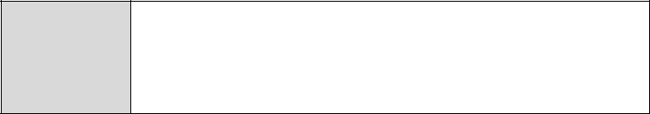

If there are 14 candies in 20%, then there are 14 candies in each of the other 20% sections of the diagram. The total number of candies in the bag is the sum of all the quantities:

14 + 14 + 14 + 14 + 14 = 70 or 14(5) = 70.

0% |  | 20% |  | 40% |  | 60% |  |  | 80% |  | 100%
 |  |  |  |  |  | ?
 |  | 14 |  | 14 |  | 14 |  |  | 14 |  | 14

Thus, there are 70 candies in a full bag.

Pg.16a pg. 16b

USE A DOUBLE NUMBER LINE

There are 14 candies in a bag that is 20% full. How many candies are in a full bag?

Step 1: Identify the Information

Known information

0% 20% 40% 60% 80% 100%

Percentage

Part

The Percent Proportion

You can use a percent proportion to solve for any one piece when given the other 3.
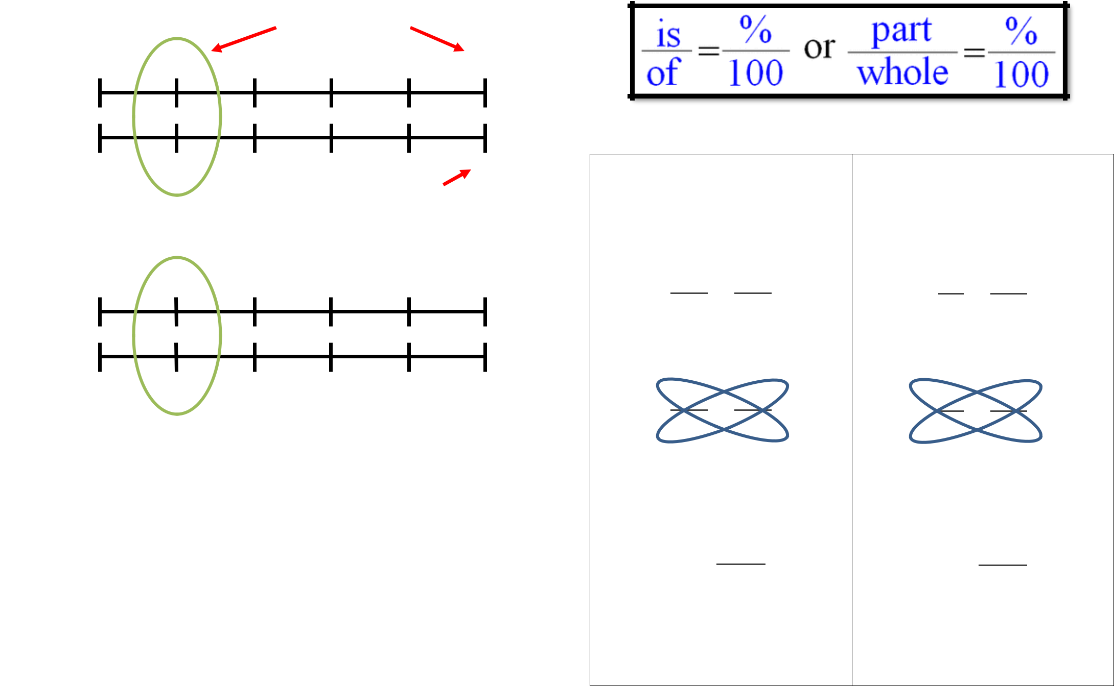

Example:

0 14 ?
Unknown information

Step 2: Fill in Equivalent Ratios to Locate the Solution

0% 20% 40% 60% 80% 100%

Percentage

Part

0 14 28 42 56 70

USE A TABLE

There are 14 candies in a bag that is 20% full. How many candies are in a full bag?

Percentage | 0% | 20% | 40% | 60% | 80% | 100%
Part | 0 | 14 | 28 | 42 | 56 | 70

Finding a percent (part) of a number (whole):

What is 20% of 240?

First, set up your proportion:
20
⁼

Then solve by cross
multiplying:
20
⁼
• 100 = 240 • 20
• 100 = 4800
4800
⁼
100
= 48

48 is 20% of 240.

Finding the whole given the percent (part):

60 is 75% of what number?

First, set up your proportion:

- 75 ⁼ 100

Then solve by cross multiplying:

- 75 ⁼ 100
60 • 100 = • 75
6000 = • 75
6000
= ₇₅
= 80

60 is 75% of 80.

Pg.17a

pg. 17b

You Try:

Use one of the methods you have learned to solve the following problems.

1) What is 5% of 200? 2) 8 is 40% of what number?

3) What is 15% of 80? 4) 18 is 25% of what number?

5) What is 25% of 60? 6) 62 is 50% of what number?

Problem Solving with Percents

- Martha put 20% of her paycheck in the bank. If her paycheck was $150, how much did she put in the bank?

  - Should your answer be MORE or LESS than $150?

  - Solution =

  - Write your answer in a complete sentence:

- Ethan got 90% of the problems correct on a quiz. If he got 27 problems correct, how many problems were on the quiz?

  - Should your answer be MORE or LESS than 27?

  - Solution =

  - Write your answer in a complete sentence:

- Whitney bought a pair of jeans that cost $25. If tax is 5%, how much tax will she pay?

  - Should your answer be MORE or LESS than $25?

  - Solution =

  - Write your answer in a complete sentence:

- Ellis’ bill at Red Lobster was $18.50. If he gives his server a 20% tip, how much tip will he leave?

  - Should your answer be MORE or LESS than $18.50?

  - Solution =

  - Write your answer in a complete sentence:

Pg.18a pg. 18b

Tips, Taxes and Discounts
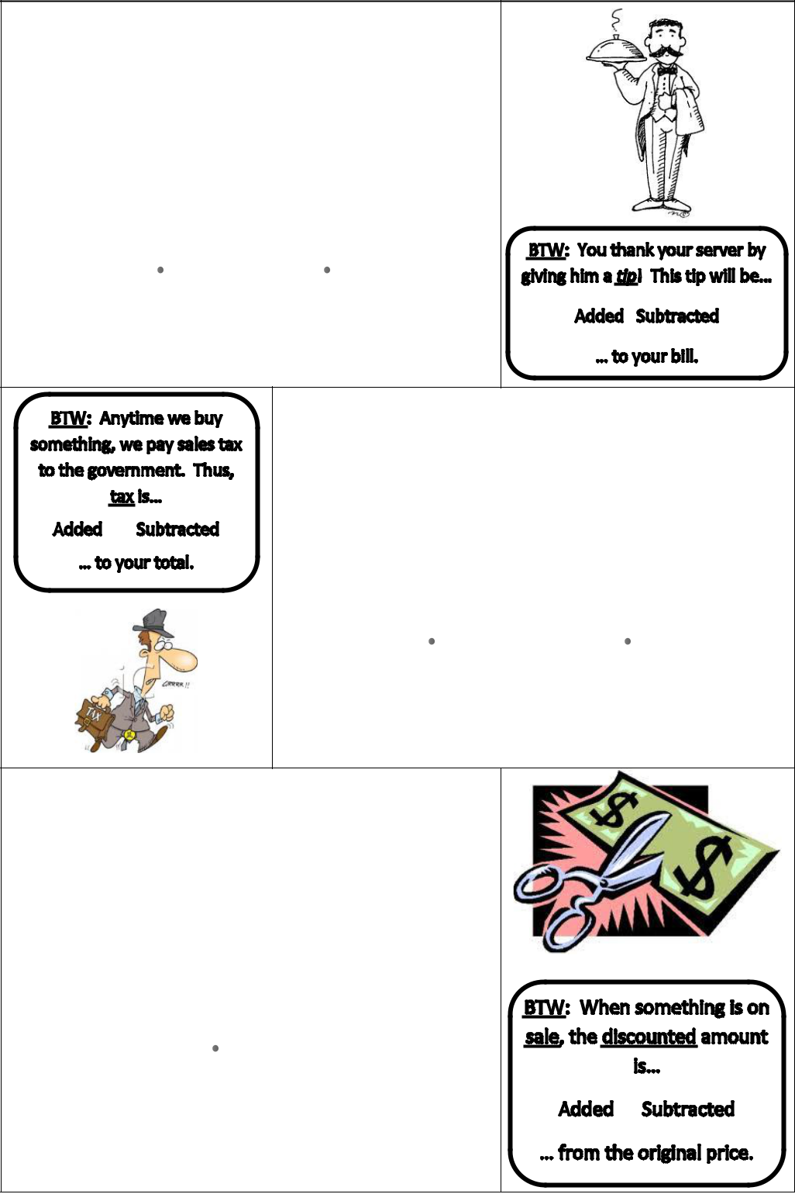

Tips: If my bill is $25, how much should I tip and what is my total?

EQ: What is 20% of $25?

Step 1: Find key words!

Step 2: Change all percents to decimals or fractions!

Step 3: Substitute key words in your question:

What is 20% of $25 means

y =.20 25 OR y = 1/5 25

Y (tip) = $5

Step 4: Add your tip to your total!

$25 + $5 tip= $30 total

Taxes: A shirt costs $ 25. If taxes are 5%, what will my total be?

EQ: What is 5% of $25?

Step 1: Find key words to tell you what to do!

Step 2: Change all percents into decimals or fractions!

Step 3: Substitute key words into your essential question:

Y = .05 $25 OR y = 5/100 25

Y (tax) = $1.25

Step 4: Add your tax to your total!

$25 + $1.25 = $26.25

Discounts: If a $32 sweater is 25% off, what is the sale price?

EQ: What is 25% of $32?

Step 1: Find key words to tell you what to do!

Step 2: Change all percents into decimals or fractions!

Step 3: Substitute key words into your
essential question:

Y = .25 32 OR Y = 25/100 • 32

Y (discount) = $8

Step 4: Subtract your discount from your
original price!

$32 - $8= $24

Pg.19a
Selecting Appropriate Units of Measurement

When measuring something, you need to first figure out what the APPROPRIATE measure would be. The “benchmarks” below can give you a good idea of what each measurement looks like.

METRICS (Base 10) CUSTOMARY (USA)
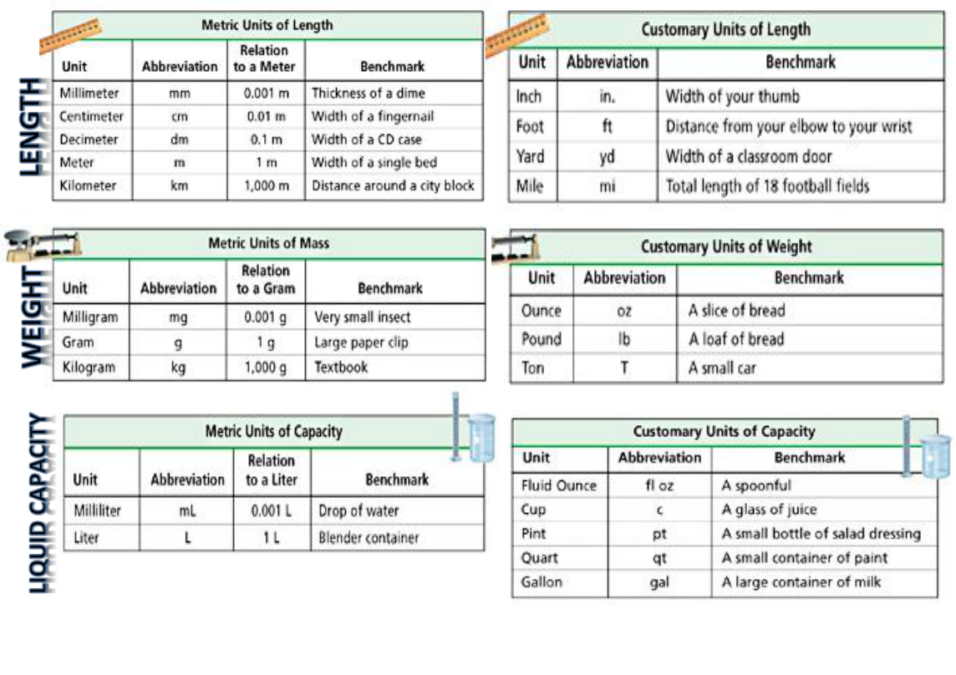

To find the APPROPRIATE measure,

FIRST, decide whether you are using metric or customary units.

SECOND, decide whether you are measuring, length, weight or liquid capacity. Then use your brain to decide which unit of measure makes the most sense!

pg. 19b

Example:

Jacob is 66 inches tall. How many feet tall is he?

MODELING THE PROBLEM
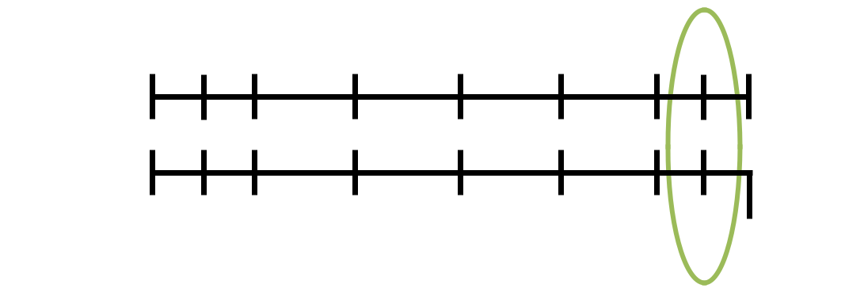

0 6 12 24 36 48 60 66 72
Inches

Feet
0 | 1 |  | 1 | 2 | 3 | 4 | 5 | 5 | 1 |  | 6
 | 2 |  |  |  |  |  |  | 5 | 2

This picture shows that 66 inches = 5 ½ feet.

USING PROPORTIONS
66 in = _____ ft |  | =
 | =
So, 66 in. = 5.5 ft | = .

Remember: A proportion shows that two ratios are equivalent.

Use a conversion factor for one of the ratios.

You Try:
1) | 6 tons = _______________ lbs.
2) | 21 ft = _______________ yds. |  | Always think about
2) |  |  | looking for patterns…
3) | _______________ cups = 28 fl. oz. |  | How many inches are in 2 feet?
4) | 3 mi = _______________ yds.
5) | 18 yds. = _______________ in.
6) | 6 pts = _______________ gal
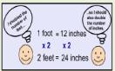

Pg.20a pg. 20b

Solve the unit conversion problem by using proportion

Solve the unit conversion problem by using proportion
You can use a unit conversion factor to change, or convert, measurements from one unit to another. A unit conversion factor is a fraction in which the numerator and denominator represent the same quantity, but in different units.

Example :
18 centimeters as inches ( 1 in = 2.54 cm)
= = = =

2.54x =18

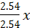= = x=

X 7.08

You try:
- 51 centimeters as inches ( 1 in = 2.54 )

- 16 inches as centimeters ( 1 in = 2.54 cm)

- 49 centimeters as inches ( 1 in = 2.54 cm

Pg.21a

- 17 inches as centimeters ( 1 in = 2.54 cm)
Pg.20a

2 inches as centimeters( 1 in = 2.54 cm)

- 10 inches as centimeters( 1 in = 2.54 cm)

- 34 centimeters as inches ( 1in = 2.54 cm)

- 13 centimeters as inches (1in = 2.54 cm)
pMath 6 – Unit 2: Rates, Ratios &

Pg.21b

MATH 6—UNIT 2: RATES, RATIOS&
Proportional Reasoning Review

Knowledge and Understanding

- What is a ratio?

- What is a rate?

- What is a unit rate?

- What is a percent?

Proficiency of Skills

5. Fill in the ratio table:

9 | 18 |  |  | 45
12 |  | 36 | 48

- 80 is 25% of what number? __________

- Find 30% of 70. __________

- Write the ratio as a unit rate: $27 for 9 tickets. __________

Application

- Jaden drove 260 miles in 4 hours. Jada drove 210 miles in 3 hours. Who drove at the fastest rate of speed? How do you know?

  - Who drove the fastest? __________

  - How do you know?

- A circus elephant is going to stand on a ball. Lulu the Elephant weighs 2 Tons. If the ball can hold up to 3,000 pounds, will Lulu make it? Explain your answer.

- The table below shows the number of each item sold at the concession stand. What might the ratio 3:4 represent?
Item | Quantity Sold
Popcorn | 20
Nachos | 15
Hot Dog | 25
Candy Bar | 30

- The ratio of boys to girls in a class is 4:8. If there are 24 students in the class, how many are boys?

- In a class of 40 students, 30% DID return their permission slips for the school field trip. How many students did NOT return their permission slips?

- The table below shows the cost for varying number of books. If the rate stays the same, determine the value of n.
Number of | Cost
Books | Cost
6 | $24
10 | $40
12 | $48
20 | N

Pg.22a

Pg.22b

- Barber Middle School held a car wash as a fundraiser. Out of the 50 vehicles that were washed, 15 were trucks. What percent were trucks?

- The graph below compares cups to pints. Which of the following ordered pairs would also satisfy this relationship?
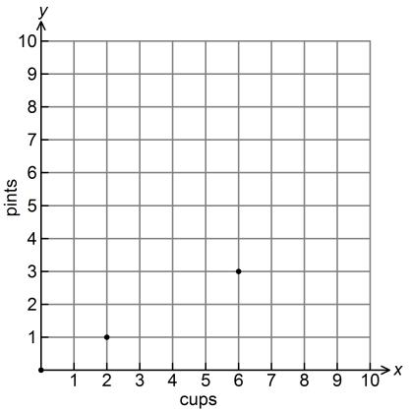

A. (1, 2) B. (2, 4) C. (2, 0) D. (4, 2)

- Michael’s paycheck last week was $146.50. He would like to put 20% of his earnings in his savings account. How much money should he put in his savings account?

a. $5.0 | b. $15.2 | c. $29.3 | d. $88.2
2 | 2 | 0 | 7

Pg.23a

- The prices of 4 different bottles of lotion are given in the table. Which size bottle is the BEST value?
Size | Price
25 ounces | $4.50
15 ounces | $1.80

  - The 25-oz bottle

  - The 15-oz bottle

  - They both have the same unit price

  - Neither

- Driving at a constant speed, Daisy drove 240 miles in 6 hours. How far would she drive in 1 hour? 15 hours?

- Chompers is 76 cm long. How many mm is this?

a. .76 mm b. 7.6 mm c. 760 mm d.7,600 mm

Pg.23b

