Unit 1
Number System Fluency

Greatest Common Factor (GCF)
Least Common Multiple (LCM)
Long Division
Operations with Decimals
Dividing Fractions

Unit 1: Number System Fluency
Standards, Checklist and Concept Map
Georgia Standards of Excellence (GSE):
MGSE6.NS.2: Fluently divide multi-digit numbers using the standard algorithm.

MGSE6.NS.3: Fluently add, subtract, multiply, and divide multi-digit decimals using the standard algorithm for each operation.

MGSE6.NS.1: Interpret and compute quotients of fractions, and solve word problems involving division of fractions by fractions, e.g., by using visual fraction models and equations to represent the problem. For example, create a story context for (2/3) ÷ (3/4) = 8/9 because ¾ of 8/9 is 2/3. (In general, (a/b) ÷ (c/d) = ad/bc.) How much chocolate will each person get if 3 people share ½ lb of chocolate equally? How many ¾-cup servings are in 2/3 cup of yogurt? How wide is a rectangular strip of land with length ¾ mi and area ½ square mi?

MGSE6.NS.4 : Find the greatest common factor of two whole numbers less than or equal to 100 and the least common multiple of two whole numbers less than or equal to 12. Use the distributive property to express the sum of two whole numbers 1-100 with a common factor as a multiple of a sum of two whole numbers with no common factor. For example, express 36 + 8 as 4(9 + 2).

What Will I Need to Learn??

________ I can divide numbers using the standard algorithm
________ I can interpret & solve division word problems
________ I can add and subtract decimals
________ I can multiply decimals
________ I can divide decimals
________ I can divide fractions using an algorithm
________ I can use pictures to represent division of fractions
________ I can find the GCF of 2 numbers < 100
________ I can find the LCM of 2 numbers < 12
________ I can solve real-world problems involving the number system

Vocabulary
Term | Definition
Algorithm | A step-by-step method used to solve a problem
Difference | The result when two numbers are subtracted
Dividend | The number being divided
Divisibility | A number has divisibility when it can be divided evenly without a remainder
Divisor | A number that divides into the dividend
Factor | A whole number that divides exactly into another number
Greatest Common Factor (GCF) | The biggest number that will divide two or more numbers exactly
Least Common Multiple (LCM) | The smallest number that is the multiple of two or more numbers
Multiple | The product of a number and any whole number
Place value | The value of a digit depending on its place in a number
Prime number | A number that has exactly two factors, one and itself
Product | The result when two quantities are multiplied
Quotient | The number that results from dividing one number by another
Reciprocal | One of two numbers whose product is 1; the result of “flipping” a fraction
Simplify | To reduce the numerator and denominator of a fraction to the smallest numbers possible
Remainder | The part “left over” in division.
Sum | The result of adding
Unit 1 – Vocabulary – You Try
Term | Illustration or Example
Algorithm
Difference
Dividend
Divisibility
Divisor
Factor
Greatest Common Factor (GCF)
Least Common Multiple (LCM)
Multiple
Place value
Prime number
Product
Quotient
Reciprocal
Simplify
Remainder
Sum
Divisibility Rules
Divisibility rules help you determine if a number can be evenly divided into another number.

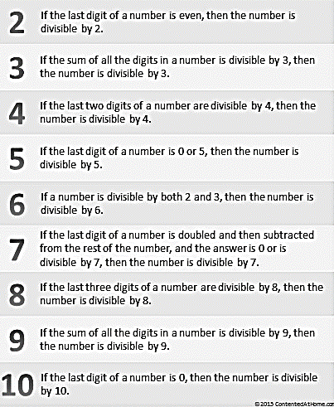
Divisibility Rules Practice
For each number below, test the divisibility rules for 2, 3, 4, 5, 6, 9, and 10 and circle which numbers they are divisible by. Some numbers are divisible by several numbers but some may not be divisible by any. Use your notes!

- 42: 2 3 4 5 6 9 10
- 64: 2 3 4 5 6 9 10
- 540: 2 3 4 5 6 9 10
- 100: 2 3 4 5 6 9 10
- 139: 2 3 4 5 6 9 10
- 612: 2 3 4 5 6 9 10
- 30: 2 3 4 5 6 9 10
- 124: 2 3 4 5 6 9 10
- 126: 2 3 4 5 6 9 10
- 4428: 2 3 4 5 6 9 10
- 513: 2 3 4 5 6 9 10
- 330: 2 3 4 5 6 9 10
Factors and Products
Factors are whole numbers that multiply together to make a product.
Factor
Factor
2 • 3 = 6
Product
Products are answers you get when you multiply factors.
Example:
Find the factors of 24.
`
24
1 | 24
2 | 12
3 | 8
4 | 6

Use a factor rainbow. Use a factor table.

1 2 3 4 6 8 12 24
The factors of 24 are: 1, 2, 3, 4, 6, 8, 12 and 24

You Try:
Find all of the factors of the following numbers.
1) 18 2) 60 3) 45

4) 120 5) 19 6) 39
Multiples
Multiples are the product of a number and any whole number.
Example: Find the first 10 multiples of the number 2.
2: 2, 4, 6, 8, 10, 12, 14, 16, 18, 20
2: 2, 4, 6, 8, 10, 12, 14, 16, 18, 20
You Try:
Find the first 6 multiples of the following numbers.
1) 7 2) 8 3) 5

4) 12 5) 20 6) 31

Extra Practice with Factors and Multiples
Find all of the factors of each number and the first 6 multiples.
1) 11
Factors:
Multiples:

2) 48
Factors:
Multiples:
GCF (Greatest Common Factor)
Definition:

Method #1:
Algorithm:

Method #2:
Algorithm:

GCF Examples
There are two ways to find the GCF (Greatest Common Factor). You can simply list the factors or you can use the SLED method.
Example:
Find the GCF by making a list of all of the factors.
24: 1, 2, 3, 4, 6, 8, 12, 24
30: 1, 2, 3, 5, 6, 10, 15, 30
The largest factor that 24 and 30 share in common, is 6, so 6 is the GCF.

Find the GCF by using the SLED method.
First, set up a sled with the numbers on it. Divide by the common factors that the numbers share. Keep dividing until the only common factor that remains is 1.
2
24 30
4 5
12 15
3

The GCF is the product of the factors on the left, so the GCF is 2 x 3 which is 6. “GCF is on the LEFT!”
You Try:
Find the GCF for the following sets of numbers.
1) 24 and 72 2) 90 and 75 3) 54 and 18
LCM (Least Common Multiple)
Definition:

Method #1:
Algorithm:

Method #2:
Algorithm:

LCM Examples
There are two ways to find the LCM (Least Common Multiple). You can simply list multiples of each number until you find one they have in common or you can use the SLED method.
Example:
Find the LCM by making a list of the multiples.
10: 10, 20, 30, 40, 50, 60, 70, 80
12: 12, 24, 36, 48, 60
The smallest multiple that 10 and 24 share in common is 60, so 60 is the LCM.

Find the LCM by using the SLED method.
2
10 12

5 6
The LCM is the product of all of the factors, so the LCM is 2 x 5 x 6 which is 60. “LCM is all of them!” Notice that the factors form the letter “L” for LCM.
You Try:
Find the LCM for the following sets of numbers.
1) 8 and 6 2) 12 and 20 3) 25 and 100
GCF and LCM
Find the GCF and LCM for each set of numbers.
1) 15 and 40 2) 5 and 10
GCF: LCM: GCF: LCM:

3) 12 and 54 4) 24 and 64
GCF: LCM: GCF: LCM:

5) 7 and 10 6) 7 and 49
GCF: LCM: GCF: LCM:

7) 12 and 18 8) 16 and 36
GCF: LCM: GCF: LCM:

GCF and LCM in Problem Solving
_____________ is on the ______________
AND
____________ is all of ________________

GCF | LCM
TIP #1 – Look for KEY words that will tell you if you’re finding GCF or LCM!

You Try:
Circle the key words in the problems below that let you know if you need to find the GCF or the LCM.
1) Johnny is making goodie bags that include a lollipop and bubbles. If the lollipops come 4 to a pack, and the bubbles come 6 to a pack, what is the smallest number of bags that he can make and not have anything left over?
2) Shannon is making identical balloon arrangements for a party. She has 24 white balloons and 16 blue balloons. She wants each arrangement to have the same number of each color. What is the greatest number of arrangements that she can make if every balloon is used?
TIP #2 – Draw a picture! Sometimes visualizing the problem will help it to make more sense!
Example 1:
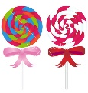
Johnny is making goodie bags that include a lollipop and bubbles. If the lollipops come 4 to a pack, and the bubbles come 6 to a pack, what is the smallest number of bags that he can make and not have anything left over? How many packs of lollipops and bubbles should he buy?
1 Pack
2 Packs
3 Packs
2 Packs
1 Pack

Draw 4 lollipops and 6 bubbles until there are no items “left over”, until all of the lollipops have a matching bottle of bubbles.

The is “smallest”, so you’re finding LCM.
The smallest number of bags w/o leftovers = 12. He needs 3 packs of lollipops and 2 packs of bubbles.
Example 2:
Shannon is making identical balloon arrangements for a party. She has 24 white balloons and 16 blue balloons. She wants each arrangement to have the same number of each color. What is the greatest number of arrangements that she can make if every balloon is used?
Draw the balloons in the largest possible number of equal groups
WWWBB WWWBB WWWBB WWWBB
WWWBB WWWBB WWWBB WWWBB
The is “greatest”, so you’re finding GCF.
She can make 8 balloon arrangements.
You Try:
1) There are 40 girls and 32 boys who want to participate in 6th grade intramurals. If each team must have the same number of girls and the same number of boys, what is the greatest number of teams that can participate in intramurals? How many girls and boys will be on each team?
# of teams _________
# of girls _________
# of boys _________

2) Fred is making some hot dogs for his company picnic. Buns come 12 to a pack and hot dogs come 8 to a pack. What is the fewest number of hot dogs he can make and not have any leftover buns or hot dogs? How many packs of buns and packs of hot dogs should he buy?
# of hot dogs with buns that can be made _________
# of packs of buns _________
# of packs of hot dogs _________

3) At the Regal Cinemas grand opening, every 8th customer will receive a free drink and every 10th person will receive a free movie rental. What number customer will be the first to receive both gifts?
# of customer to receive both gifts __________

4) Stephen is making a garden of 36 tomato plants and 45 corn plants. He wants to plant as many rows as possible, so that each row has the same number of tomatoes plants and the same number of corn plants, and each row of corn has the same amount. What is the maximum number of rows that Stephen can plant? How many tomato plants will be on each row? How many corn plants will be on each row?
# of plants per row _________
# of tomato plants per row _________
# of corn plants per row _________

5) Dayvon had a collection of baseball cards that he wants to divide evenly into his albums. He has 36 Braves cards and 48 Cubs cards. What is the greatest number of albums he can use? How many Braves cards and Cubs cards will be in each album?
# of albums __________
# of Braves cards per album __________
# of Cubs cards per album __________

6) Two pigs entered a race around a track. Piggly takes 6 minutes to run one lap. Wiggly takes 5 minutes to run one lap. If both pigs begin the race at the same time, what is the shortest amount of minutes it will take for them to be back at the starting line? How many laps will each pig have made at that time?
Time for both pigs to be at starting point __________
# of laps for Piggly __________
# of laps for Wiggly __________
7) Enzo and Beatriz are playing games at their local arcade. Incredibly, Enzo wins 5 tickets from every game, and Beatriz wins 11 tickets from every game. When they stopped playing games, Enzo and Beatriz had won the same number of total tickets. What is the minimum number of games that Enzo could have played?
# of games that Enzo could have played __________

8) Tim has 39 pairs of headphones and 13 music players. Tim wants to sell all of the headphones and music players in identical packages. What is the greatest number of packages Tim can make?
# packages Tim can make __________

9) Audra has two rolls of streamers to use in decorating the school gym for a pep rally. The red streamers are 64 feet long and the blue streamers are 72 feet long. What is the maximum length each streamer can be so that they are all of equal length? How many red streamers would she have? How many blue streamers would she have?
Length of each streamer __________
# of red streamers __________
# of blue streamers __________

Long Division
The purpose of division is to determine how many times the divisor fits into the dividend.
Division is the inverse (opposite operation) of multiplication. You can use multiplication to “undo” or check your answer. Multiply the quotient by the divisor and you should get the dividend.
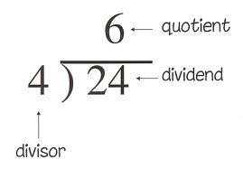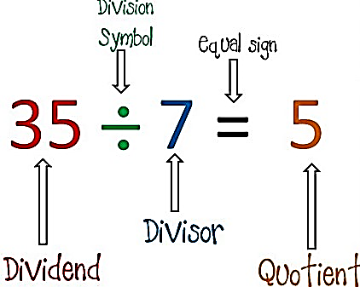
Example:
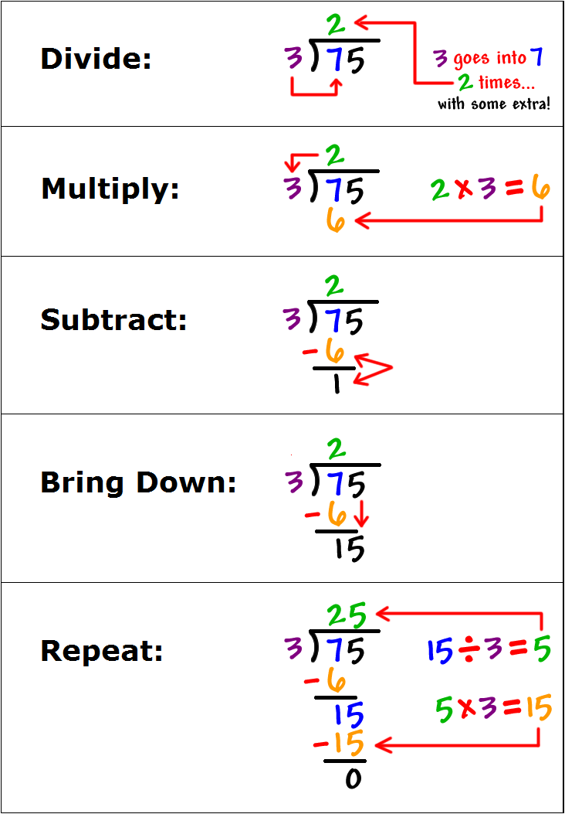
Long Division and Remainders
What is a remainder? A __________ exists when your __________ doesn’t go into your __________ evenly, meaning that you don’t have enough remaining to make another group. It is the “_________ __________” amount after you have divided.
Example:
1) 23 $÷$ 4 =

4 goes into 23 five whole times, but there are three more left. Those three won’t allow us to make another group of 4, so 3 is the remainder.
How do we write remainders? Up until this point, you have probably been writing remainders as “R 3”. Now that you know more about what a remainder is, you will need to write your remainders differently to reflect what a remainder actually represents.
We can work with remainders in one of two ways:
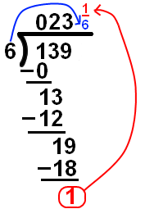
Remainders as Fractions
Divide: 139 $÷$ 6
Note: When you divide, the divisor (6)
goes into the dividend (139), 23 whole
times, but there is 1 left over that won’t
make another group of 6. 1 is the remainder.
We write it as a fraction with the remainder
over the divisor. “There is one left when we
needed six to make another whole.”
Remainders as Decimals
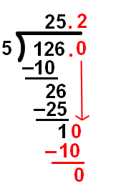
When you want to write your remainder as a decimal, you add a zero and continue to divide until you get a remainder of zero or you round your answer according to your instructions. If there is no decimal, you must add a decimal before you add a zero.

You Try:

Find the quotient and write the remainder as a fraction.

1) 154 ÷ 4 = 2) 121 ÷ 8 =

Find the quotient and write the remainder as a decimal.

3) 154 ÷ 4 = 4) 121 ÷ 8 =
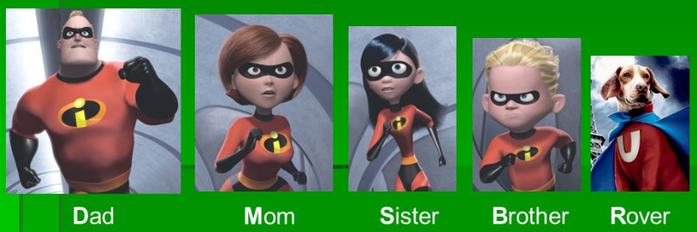
You Try:
1) 5 9 6 5 2) 11 1 8 7

3) 121 $÷$ 8 = 4) 708 $÷$ 12 =

5) $\frac{7695}{6}$ = 6) 13 2 3 5 7 6

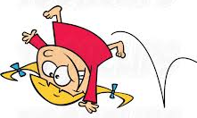
Long Division Error Analysis
Sally is a silly little girl who makes mistakes! In Column #1, analyze her work and circle her mistake. In Column #2, explain what she did wrong. In Column #3, show how Silly Sally should work out the problem correctly. Show ALL work!
$$\frac{31}{10}$$
Silly Sally’s Work  (Circle her mistake): | What did Silly Sally do wrong? | Show Silly Sally how it’s done!  (Show ALL steps!)
000
-144
144
-24
86
00
-60
60
-80
10
258
-248
-62
Long Division – What do Remainders Mean?
Remainders aren’t just random numbers. They have value and meaning. In word problems, you are given context and so you must be able to interpret what the remainder represents.
Example #1:
Mickey is making bows for Minnie. Each bow needs 7 inches of ribbon. If he has 15 inches of ribbon, how many bows can he make?
Divide: 7 15

a) Draw a picture of the problem:

b) How many bows can Mickey make?
c) What does the remainder represent?
d) Did you have to round your answer up or down? Explain.
Example #2:
Goofy’s favorite ride at the fair holds 7 people at a time. If 15 people are in line, how many times will the ride have to go for everyone in line to have a turn?
Divide: 7 15

a) Draw a picture of the problem:

b) How many times does the ride go for everyone to ride?
c) What does the remainder represent?
d) Did you have to round your answer up or down? Explain.
You Try:
1) HOMEWORK Lisa solved 448 math problems for homework over 28 days. If she solved the same number of problems each day, how many problems did she solve per day?
2) AT HOME Meg has a new bookcase for her bedroom with 6 shelves. Each shelf holds 8 books. If Meg has 50 books, how many books will not fit on the bookcase?
3) MEALS Sandra helped serve meals to 25 families. Each family received the same amount of food. If she served 275 pounds of food, how many pounds of food did each family receive?
4) BATTERIES A teacher bought a package of 17 batteries to put in her calculators. Each calculator uses 3 batteries. How many calculators can the teacher fill with batteries?
5) FOOTBALL The football team is raising money to have a new turf field installed. The cost of the turf field is $48,780. The team has 18 months to raise the money. How much do they need to raise each month?
6) WINDOWS A window washing company has a contract to wash 3,082 windows on a 23-story building. If there are the same number of windows on each floor, how many windows are there on each floor?
7) SCHOOL There are 32 students in a math class. Each table in the classroom seats 6 students. How many tables will be needed to seat all of the students?
8) DELIVERIES Mr. Thomas is delivering bricks to a construction site. His truck holds 387 bricks at one time. The builder has ordered 2,800 bricks. How many trips will Mr. Thomas have to make to deliver all the bricks?
Place Value Review
Place Value Table
Thousands | Hundreds | Tens | Ones | • | Tenths | Hundredths | Thousandths | Ten-Thousandths | Hundred-Thousandths
 |  |  | 3 | • | 4 | 5
When reading a decimal you say “and” in place of the decimal and you use the name of the column of the last digit when reading a decimal. For example, 3.45 is read as three and forty-five hundredths.
You Try:
Write the following numbers:
1) six and eight tenths
2) forty-two and sixty-one thousandths
3) seventy and twelve hundredths
4) five ten-thousandths
5) one thousand fifty-two and thirty one hundredths
Write the following numbers in words:
6) 12.345
7) 0.983
8) 9.36
9) 158.9
10) 6.4
Dividing Decimals
Dividing decimals is just like dividing any other number, but you have to make sure the decimal ends up in the right place in your answer.
Here are the basic steps for dividing decimals:
- If necessary, make the divisor a _____________ _____________ by moving the _____________ all the way to the right.
- Move the _____________ in the dividend (the number under the “house”) the same number of places that you moved it in the divisor. Add _____________ if necessary.
- Bring the _____________ straight up. (Remember, in division the decimal is very _____________ and it floats.)
- Finish by simply, _____________ as you normally would.
Examples:
1) 5 2 . 5 2) 1.25 3 . 8 7 5

You Try:
1) 2.32 $÷$ 8 = 2) 0.045 $÷$ 0.09 = 3) 16.75 $÷$ 2.5 =

4) Aleem has $416.13 that he is going to give to his 3 friends Amanda, Jennifer and Audra. If he is giving each friend the same amount, how much will each person get?

5) How many quarters are in $20?
Adding and Subtracting Decimals
Here are the basic steps for adding and subtracting decimals.
- Always ____________________ up the ____________________!
- Fill in ____________________ as placeholders at the end, especially if subtracting.
- ____________________ or ____________________.
- ____________________ the ____________________ down.
- ____________________ your work! Check whether your answer is reasonable by estimating.
Example:
1) 2.6 + 3.45 = 2) 2.37 – 1.256 =

You Try:
1) 16.75 + 5.091 = 2) 312.55 – 16.2 = 3) 29.1 – 0.68 =

4) Savannah spent $11.50 at the movies, and Quianna spent $12.75. If they paid together, using a $50 bill, how much change did they receive?
Multiplying Decimals
Here are the basic steps for multiplying decimals.
- ____________________. (You do NOT need to line up the ____________________!)
- Count the number of places behind the ____________________ in your problem. Your product must have the same number of places behind the ____________________.
Example:
1) 3.67 x 2.3 = 2) 9 • 0.54 =

You Try:
1) 8.41 x 0.5 = 2) 2.13 (3.5) = 3) 0.7 • 0.8 =

4) Hunter is building a ramp for his Tech Decks. The base will be a piece of wood that is 2.75 feet long and 2 feet wide. What is the area of the base? (Area of a rectangle = length x width.)

Operations with Decimals Practice
Answer bank:
54.2241 107.133 16.760 38.7
31.011 88.56 29.927 45.168
0.35 51.6 43.608 0.109

1) 92 – 53.3 = __________ 2) 60.4 + 28.16 = __________
3) 19 + 88.133 = __________ 4) 5.45 $÷$ 50 = __________
5) 78.38 – 34.772 = __________ 6) 8.256 $÷$ 0.16 = __________
7) 9.41 $∙$ 4.8 = __________ 8) 20.65 $÷$ 59 = __________
9) 96.927 – 67 = __________ 10) 9.513 $∙$ 5.7 = __________
11) 14.302 + 16.709 = __________ 12) 2 $∙$ 8.38 = __________
Fractions Cheat Sheet
A fraction is part of a whole.  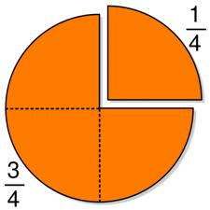 | The top number of a fraction is called the numerator. The bottom number is the denominator.  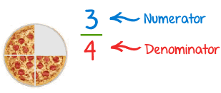
An improper fraction has a numerator that is larger than or equal to its denominator.  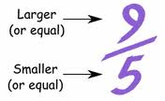 | A mixed number has a whole number AND a fraction.  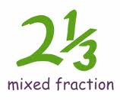
You can make any whole number into a fraction by putting it over 1!  $5=\frac{5}{1}$ | When the numerator and the denominator are the same, the fraction equals 1.  $$\frac{5}{5}=1$$
If the numerator > the denominator, the fraction’s value is greater than 1.  If the denominator > the numerator, the fraction’s value is less than 1. | The fraction bar shows division. The numerator is the dividend (the number in the “house”) and the denominator is the divisor.

Mixed Numbers to Improper Fractions
Converting mixed numbers to improper fractions:
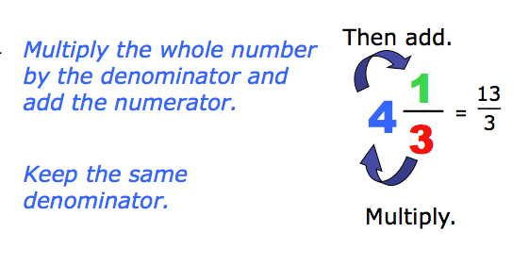
Example:
Convert $5\frac{1}{6}$ to an improper fraction.
First, shade $5\frac{1}{6}$ on the circles below:
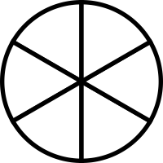
Note that there are 31 pieces shaded. 5 wholes times the six pieces in each whole plus the one extra piece equals 31. That is the new numerator. You still need 6 pieces to make a whole, so the denominator remains 6.
So, $5\frac{1}{6}$ = $\frac{31}{6}$
You Try:
Convert the mixed numbers to improper fractions.
1) 3 $\frac{1}{2}$ 2) 2 $\frac{1}{3}$ 3) 5 $\frac{2}{7}$

4) 1 $\frac{3}{7}$ 5) 22 $\frac{2}{3}$ 6) 12 $\frac{1}{12}$
Improper Fractions to Mixed Numbers
Converting improper fractions to mixed numbers:
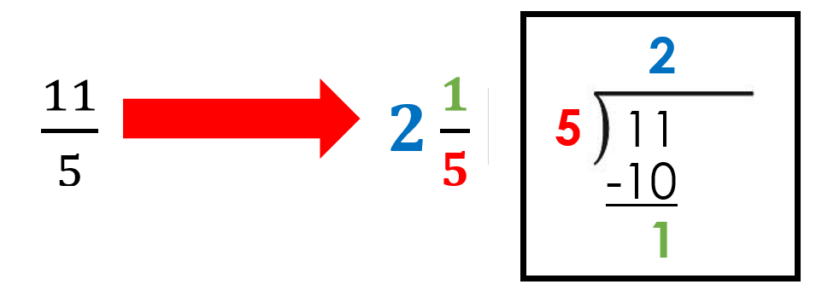
Example:
Convert $\frac{22}{5}$ to a mixed number.
First, shade in 22 pieces on the circles below:
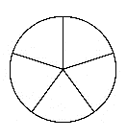
Note that you should have filled 4 whole circles with 2 left over. That is because you need 5 pieces to make a whole and there are 4 complete groups of 5 in 22 with 2 left over.
So, $\frac{22}{5}= 4\frac{2}{5}$
You Try:
Convert the improper fractions to mixed numbers.
1) $\frac{20}{7}$ 2) $\frac{33}{4}$ 3) $\frac{13}{2}$

4) $\frac{17}{3}$ 5) $\frac{40}{8}$ 6) $\frac{48}{7}$
Simplifying Fractions
To _______________ fractions you need to find a common _______________ that is shared between the numerator and the denominator. Then divide the numerator and the denominator by that common factor. You know you are done when your numerator and denominator only share a factor of __________.
Example:
Simplify $\frac{4}{8}$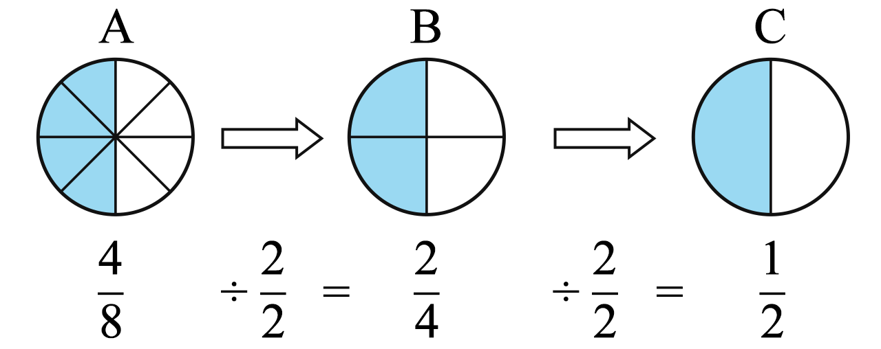
You Try:
Simplify the fractions.
1) $\frac{5}{15}$ = 2) $\frac{12}{24}$ = 3) $\frac{6}{24}$ =

4) $\frac{50}{70}$ = 5) $\frac{21}{24}$ = 6) $\frac{504}{522}$ =

Review of Multiplying Fractions
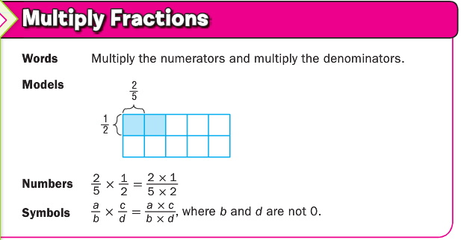
Don’t forget that if you simplify before you mutliply you won’t have to simplify your answer and you will work with simpler numbers.
Example:
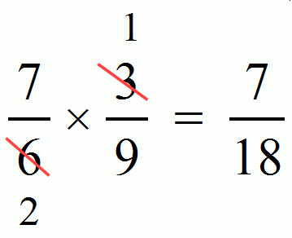
You Try:
1) $\frac{1}{2}•\frac{3}{5}=$ 2) $\frac{1}{3}•\frac{3}{4}=$ 3) $\frac{2}{3}•\frac{5}{6}=$

4) $\frac{12}{4}•\frac{7}{3}=$ 5) $1\frac{1}{5}•\frac{20}{3}=$ 6) $\frac{5}{6}•2=$
Dividing Fractions Using Models

Example:
Divide $\frac{3}{4}$ ÷ $\frac{2}{8}$ = $\frac{3}{4}$ ÷ $\frac{1}{4}$
$\frac{3}{4}$ ÷ $\frac{1}{4}$ = 3
You Try:
1) $\frac{1}{3}$ ÷ $\frac{2}{6}$ =
2) $\frac{8}{12}$ ÷ $\frac{2}{3}$ =
3) $1$ ÷ _____ = _____
4) $\frac{2}{3}$ ÷ _____ = _____
5) _____ ÷ _____ = _____
6) _____ ÷ _____ = _____
7) _____ ÷ _____ = _____

Dividing Fractions Using Common Denominators

Example:

You Try:
1) $1\frac{3}{4}÷\frac{3}{4}=$ 2) $\frac{3}{5}÷\frac{1}{4}=$

3) $\frac{5}{6}÷\frac{3}{8}=$ 4) $\frac{5}{9}÷\frac{9}{13}=$

5) $6÷3\frac{1}{3}=$ 6) $10\frac{3}{4}÷6\frac{1}{2}=$

Reciprocals
A _______________ is one of two numbers whose product is 1. It is the result of “flipping” a fraction.
Example:
Find the reciprocal.
1) $\frac{3}{4}$ the reciprocal is $\frac{4}{3}$ 2) $2$ the reciprocal is $\frac{1}{2}$

3) $4\frac{1}{5}$ = $\frac{21}{5}$ the reciprocal is $\frac{5}{21}$

You Try:
Find the reciprocal
1) $\frac{2}{3}$ 2) $\frac{3}{13}$ 3) $\frac{9}{10}$

4) 4$\frac{3}{8}$ 5) $5$ 6) 7$\frac{5}{9}$

7) $2$ 8) $10\frac{2}{19}$ 9) $3\frac{2}{3}$=
Dividing Fractions Using KCF
K – Keep the first fraction (Make sure you change all mixed numbers to improper fractions first.)
C – Change the problem from division to multiplication.
F – Flip the second fraction (change it to its reciprocal)
Example:
K (Keep) | C (Change) | F (Flip)
$$\frac{4}{5}÷\frac{2}{3}$$ | $$\frac{4}{5}÷\frac{2}{3} =$$ | $$\frac{4}{5}•\frac{3}{2} =$$
You Try:
1) $\frac{5}{8}÷\frac{2}{5}$ = 2) $\frac{3}{10}÷\frac{1}{2}$ = 3) $\frac{9}{10}÷\frac{1}{4}$ =

4) $\frac{3}{8}÷9$ = 5) $\frac{10}{11}÷\frac{5}{6}$ = 6) $\frac{5}{9}÷\frac{9}{13}$ =

7) $2\frac{5}{6}÷6\frac{4}{5}$ = 8) $3÷1\frac{1}{8}$ = 9) $3\frac{2}{3}÷2\frac{2}{3}$ =

Dividing Fractions Practice
Divide. Use any of the methods we have learned to find the quotient. Answer as a mixed number if possible.
1) $7\frac{1}{4}÷\frac{49}{5}=$ 2) $4\frac{1}{2}÷3\frac{2}{3}=$ 3) $8\frac{2}{3}÷\frac{27}{4}=$

4) $\frac{7}{2}÷\frac{10}{4}=$ 5) $\frac{1}{3}÷\frac{1}{2}=$ 6) $\frac{2}{4}÷\frac{1}{3}=$

7) $\frac{25}{3}÷\frac{14}{4}=$ 8) $\frac{2}{4}÷\frac{1}{2}=$ 9) $4\frac{1}{2}÷2\frac{2}{3}=$

10) $\frac{17}{5}÷\frac{13}{4}=$ 11) $7\frac{4}{5}÷4\frac{2}{3}=$ 12) $\frac{18}{5}÷4\frac{1}{2}=$

Math 6 – Unit 1: Number System Fluency Review
Complete the following problems to review this unit. You must show all work to receive credit!
1). Explain what it means if you are asked to solve the problem . You may use any method, but explain clearly!
2). Find the greatest common factor of 30 and 48.
3)Find the least common multiple of 10 and 6.
4). 5). 13.12 + 6 + 7.1

6) (1.25)(2.3) = 7)
8) 72 – 1.68 = 9)
10) Talia waters her plants every 4 days. She trims them every 10 days. She did both today. In how many days will she do both again?
11) A quarterback practiced for hours in 4 weeks. How many hours did he practice per week?

12) Sarah paid $4.80 for 1.2 pounds of sunflower seeds. What is the cost for one pound of sunflower seeds?

- Hot dogs are sold in packages of 8 and hot dog buns are sold in packages of 10. What is the least number of packages of each that can be bought to make hot dogs (one hot dog and one bun) with no hot dogs or buns left over?
total number of hot dogs
packs of hot dogs
packs of buns
- A group of friends has ordered 3 pizzas to share. If each person gets 1/4 of a pizza, and there is no pizza left over, how many friends split the pizza?

- Emma has $3 to buy school supplies. She buys 3 folders that are $0.55 each. She wants to spend the remaining money on pencils that are $0.05 each. How many pencils can she purchase?

- Chesney is cutting a roll of cookie dough into pieces that are $\frac{1}{3}$ inch thick, if the roll of cookie dough is $\frac{4}{6}$ inches long, which model best represents, the situation?
a.
b. 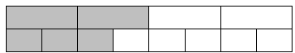
c.

