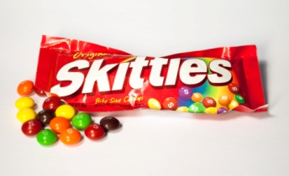
Name ____________________________________ Period: 1 2 3 4 5
Skittles Surprises
Open your bag of Skittles. Do not eat the candy until you have completed both sides of this activity sheet. Count the number of candies of each color in your bag.
Record the information in the table below.
 | Red | Green | Orange | Purple | Yellow | Total
Number of candies
PERCENT

For your data, find the following ratios:
- red to yellow _______ 2) green to purple _______ 3) orange to non-orange _______

- purple to total _______ 5) orange to red _______ 6) yellow to green _______

If you had multiple bags that had the same color ratios as your original bag, complete the table to show how many candies of each color you would have.
 | Number of candies
Number of bags | Red | Green | Orange | Purple | Yellow | Total
1
2
3
4
5
6

Describe any patterns you notice in the table above. _______________________________________________________
__________________________________________________________________________________________________
__________________________________________________________________________________________________

Applications
- Ms. Gual only completed part of her table when she opened her bag of Skittles. Based on patterns you’ve noticed with ratios, complete her table for her.
 | Number of candies
Number of bags | Red | Green | Orange | Purple | Yellow | Total
1 |  |  |  | 2
2 |  | 10 | 8
3 | 9
4 |  |  |  |  | 12 | 68

- A bag of Skittles contains green and purple candies in the ratio of 3 green to 4 purple. If there are 24 purple candies in the bag, how many are green?

- A bag of Skittles contains red and yellow candies in the ratio of 2 red to 5 yellow. If there are 10 red candies in the bag, how many are yellow?

- A defective bag of Skittles has only 3 colors – red, yellow, and green – in the ratio of 1:2:5. If there were a total of 32 pieces of candy, how many were of each color? Justify your answer.

.

