NAME:_______________________________ PERIOD: 1 2 3 4 5
TAPE DIAGRAMS & DOUBLE NUMBER LINES
TAPE DIAGRAMS : EXPRESSION
Example 1
Expression $\frac{part}{whole} ∙ \frac{\%}{100}$
$\frac{x}{30} ∙ \frac{20}{100}$ = or 0.20 x 30 =
X=6 ,so 20% of 30 is 6.

What is 20% of 30?
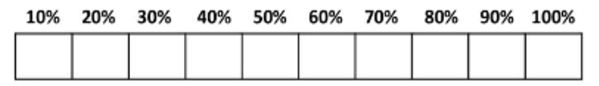
DOUBLE NUMBER LINE:
0 30
PART
WHOLE
0% 10% 20% 30% 40% 50% 60% 70% 80% 90% 100%

Example 2
At Barber Middle School, 45% of the students bring their lunch from home out of 300 students. How many students bring their lunch from home?
Expression $\frac{part}{whole} ∙ \frac{\%}{100}$

(HINT:FIND 5%)

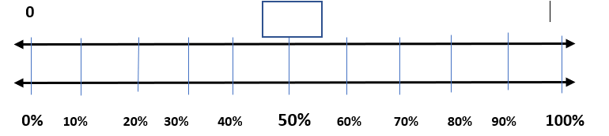
Students at Barber
% of Students

Example 3
Laurie bought a pair of shoes that was on sale for 40% off. If the shoes originally cost $50.00. How much did she save? How much did she pay for the shoes?
Expression $\frac{part}{whole} ∙ \frac{\%}{100}$

____________________
____________________
1.) There are 75 teachers at the Barber Middle School in Acworth ,GA. 15 of them teach mathematics. What percent of the teachers at the Barber teach mathematics?
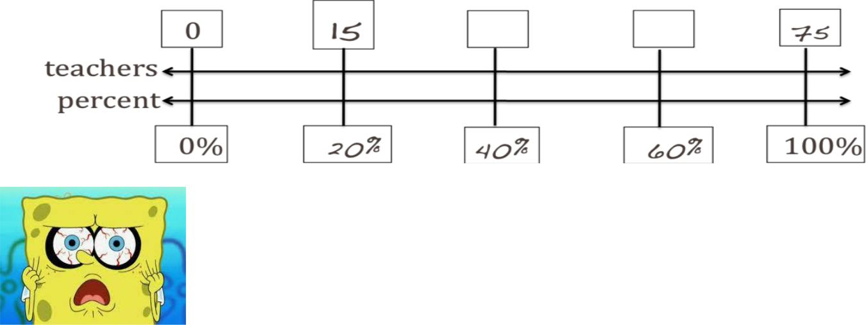

Your friend Bob was absent from school the day your teacher taught you how to use double number lines to solve percent problems. Now he’s really confused! Help Bob understand how to solve the problem.

1) In the first step for the problem above you write in 75 above the 100%. Explain to Bob why you do that: ____________________________________________________________________________________________________________________________________________

2) Then you put 15 above 20%. Explain to Bob how to find out that 15 belongs in that box.
____________________________________________________________________________________________________________________________________________________________
3) What is the answer to the problem? ___________ How do you know that?
____________________________________________________________________________________________________________________________________________________________

